Discover Leh Ladakh with INTRO TRAVELS INDIA
Leh Ladakh, often called the “Land of High Passes,” is one of India’s most breathtaking travel destinations, famous for snow-capped mountains, crystal-clear lakes, ancient monasteries, dramatic landscapes, thrilling road trips, and adventure tourism. Located in the northernmost region of India, Ladakh offers an unforgettable experience for nature lovers, bikers, photographers, adventure seekers, and spiritual travelers.
Whether you are planning a bike trip, family vacation, honeymoon, or adventure expedition, Leh Ladakh promises a once-in-a-lifetime journey.

Why Visit Leh Ladakh?
- Stunning Himalayan landscapes
- Famous high-altitude lakes
- Adventure bike & road trips
- Ancient Buddhist monasteries
- Snow-covered mountain passes
- Camping under starry skies
- Peaceful spiritual atmosphere
- Perfect destination for photography

Top Tourist Attractions in Leh Ladakh
1. Leh
The heart of Ladakh and the main gateway to the region.
Top attractions:
- Leh Palace
- Shanti Stupa
- Leh Market
- Local monasteries
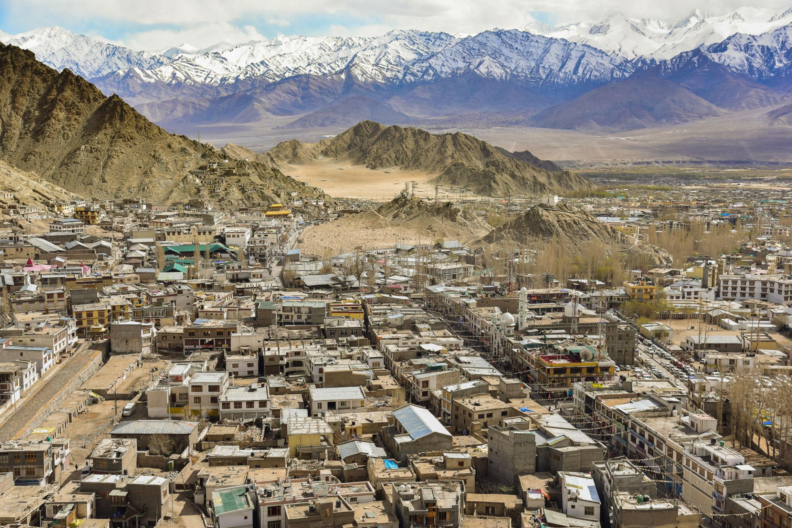
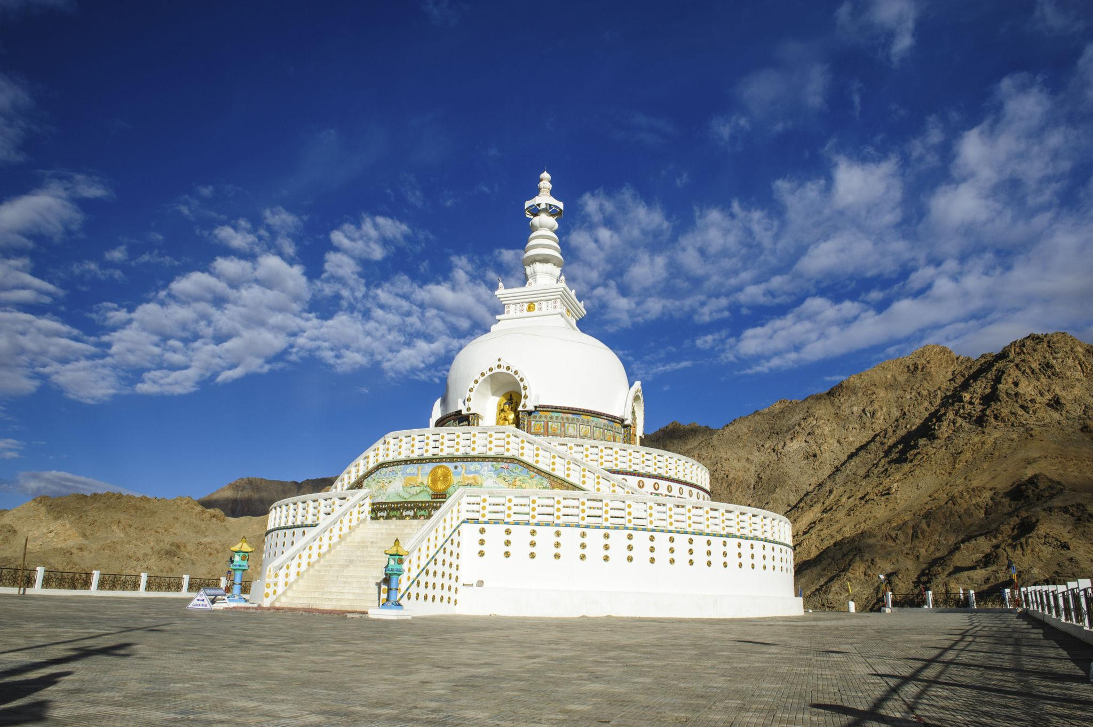
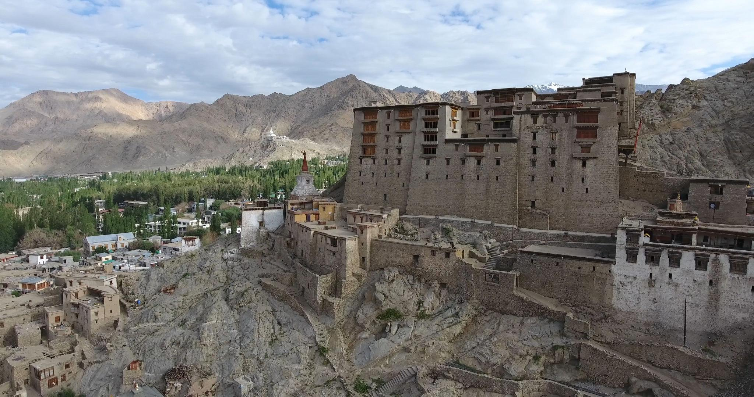
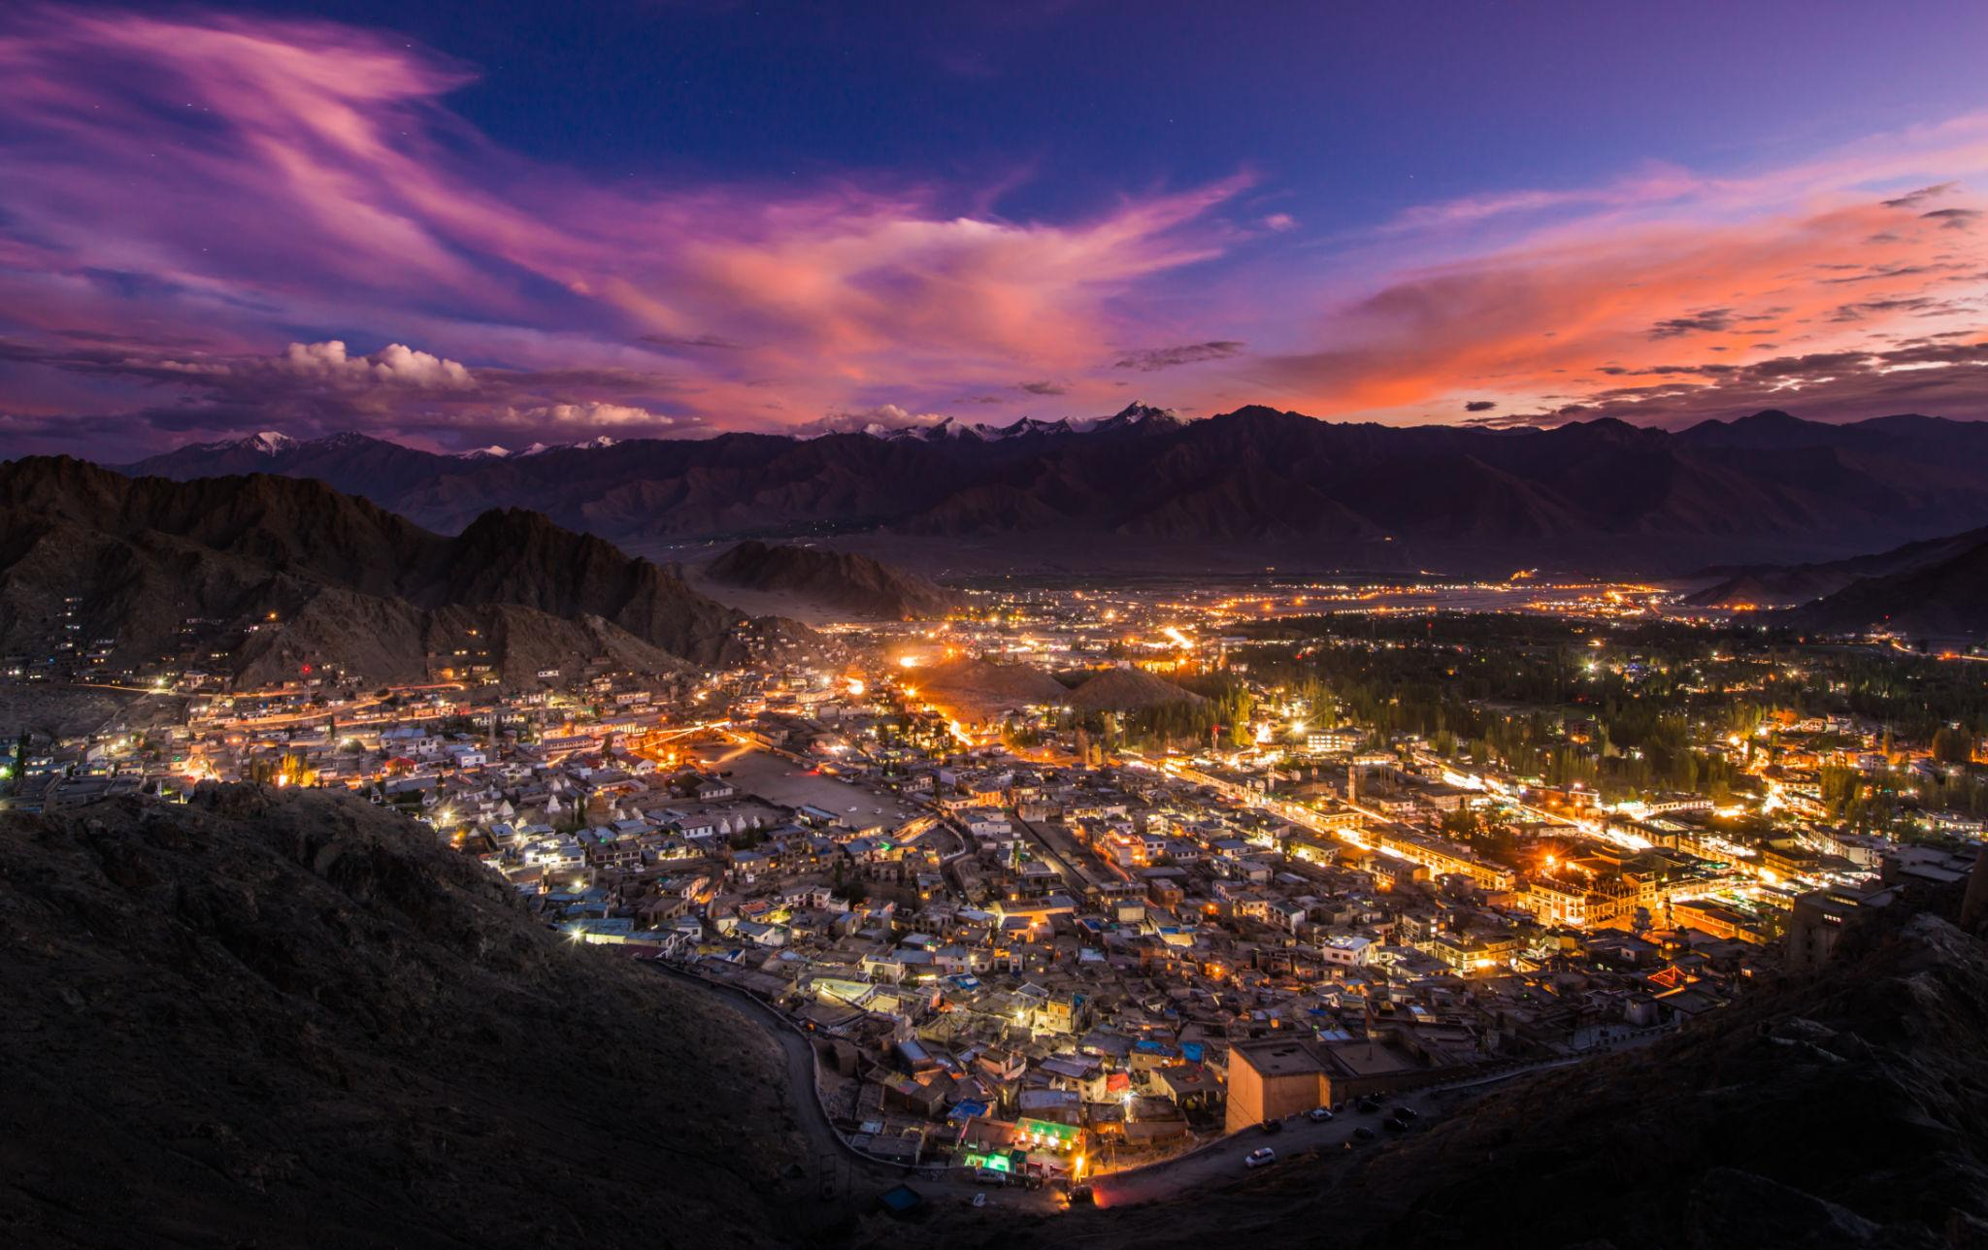
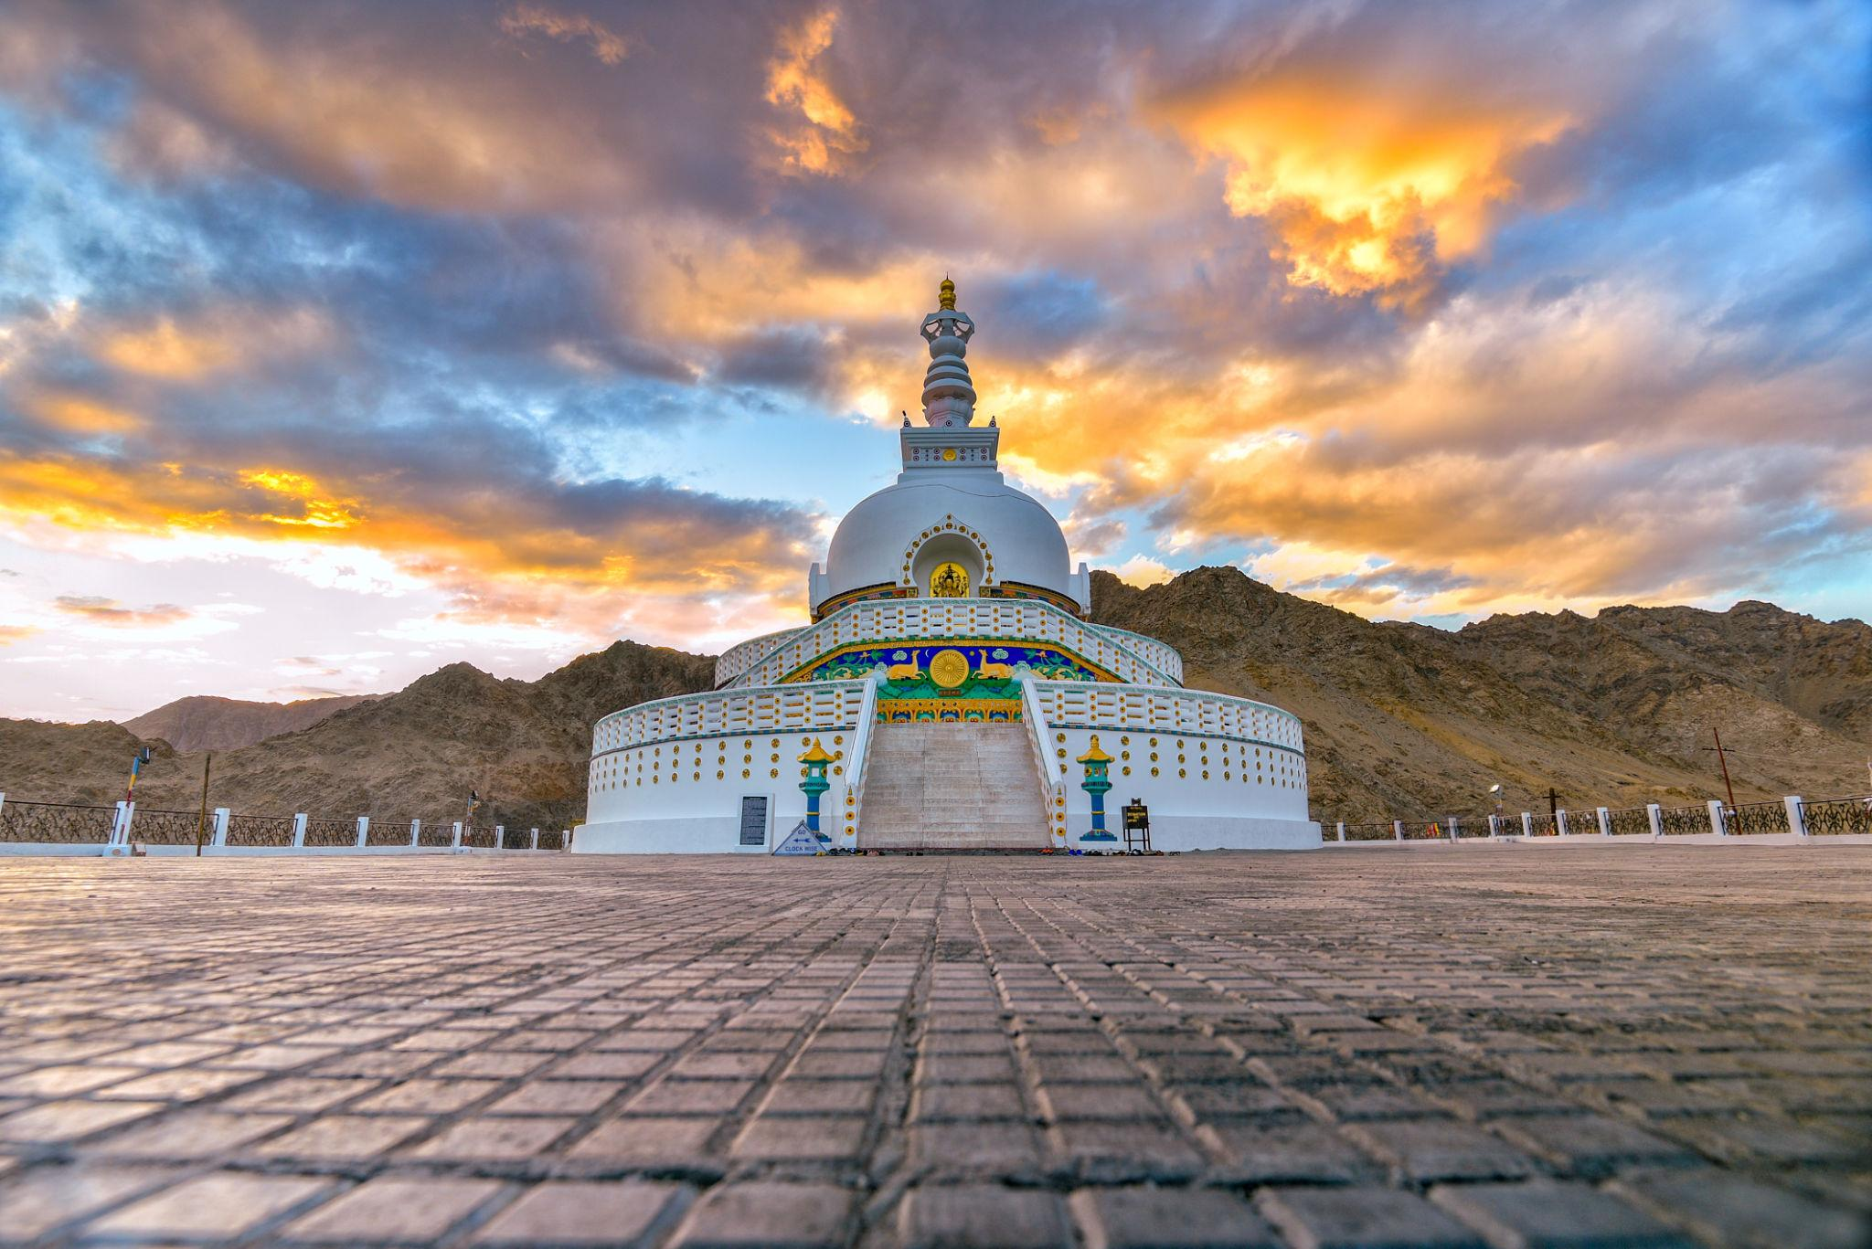
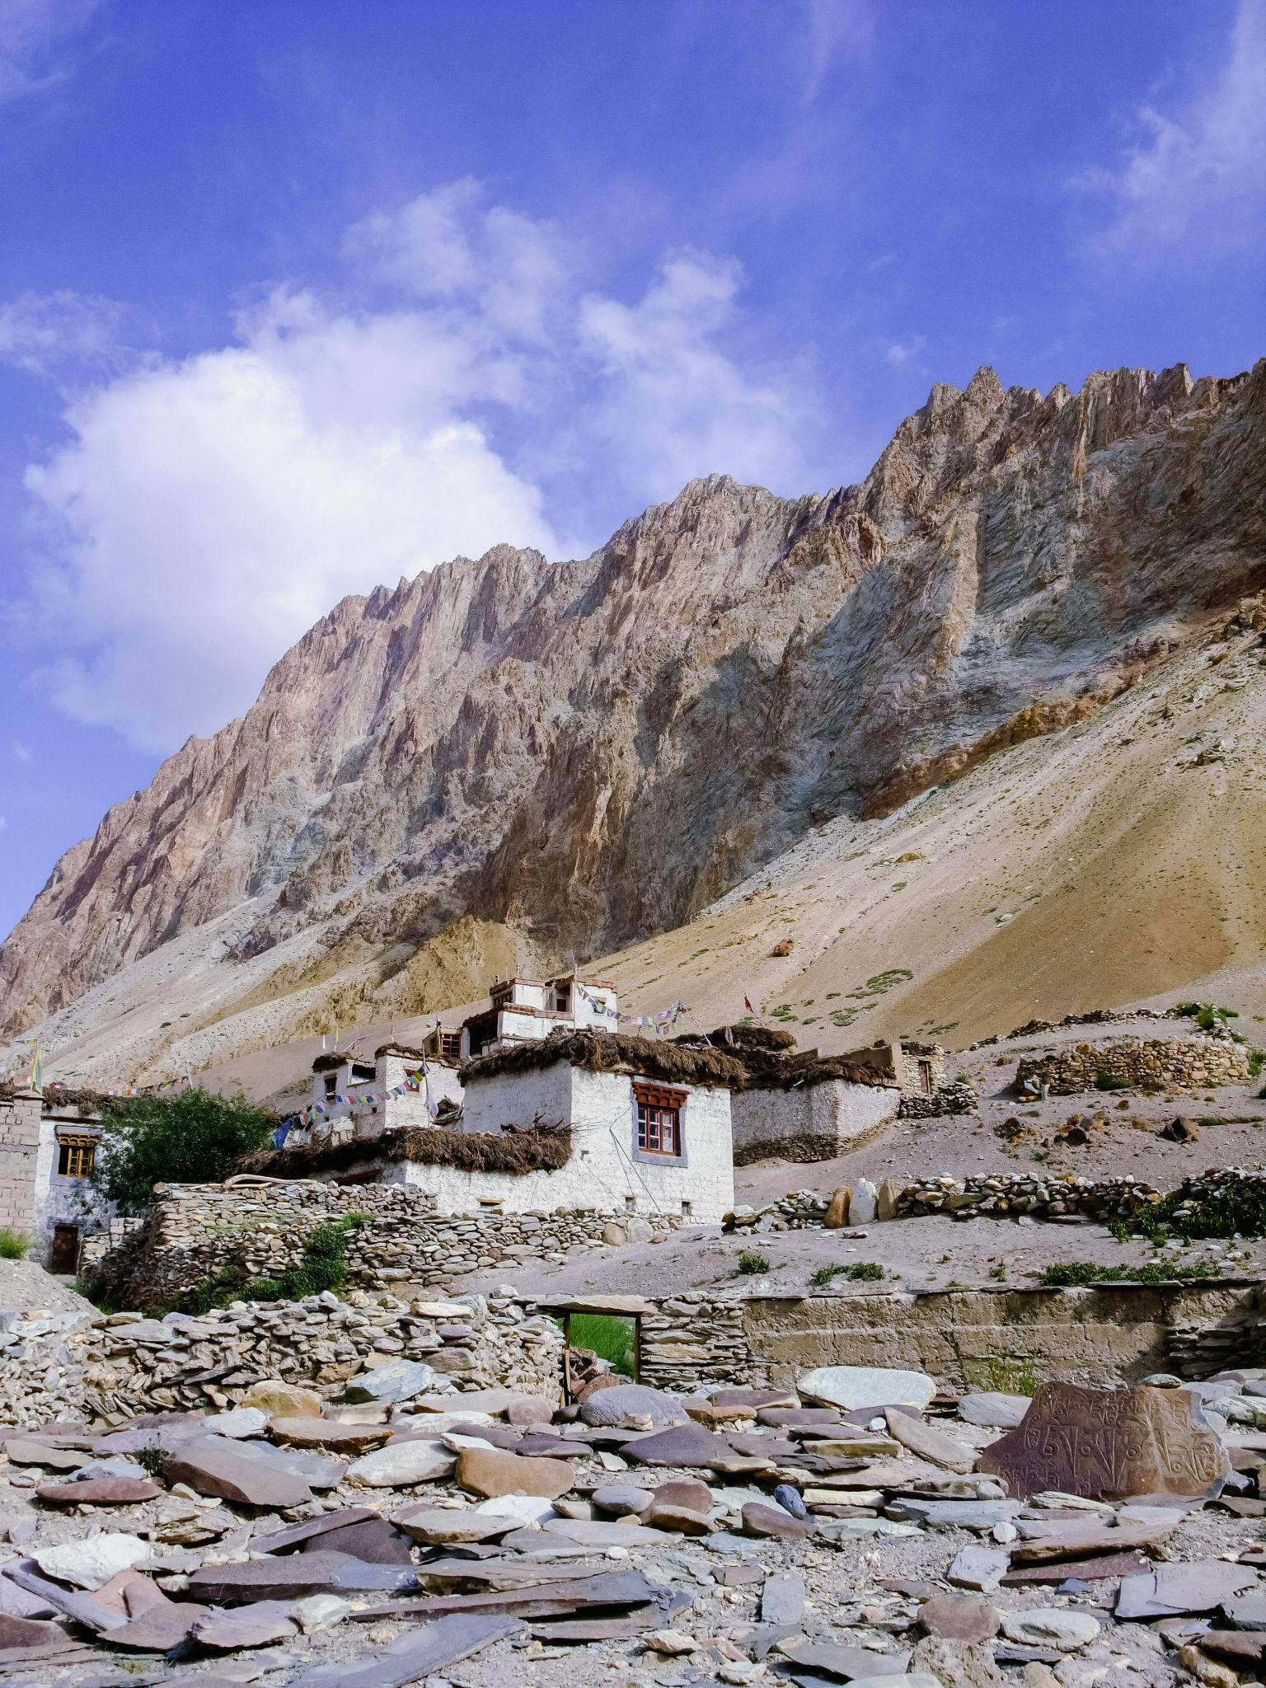
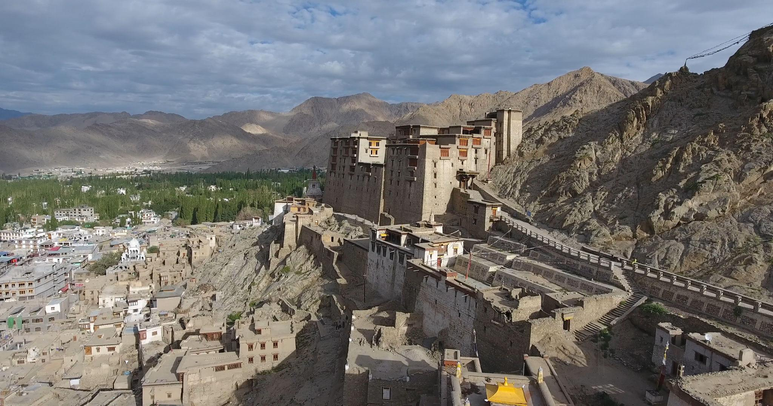

2. Pangong Lake
One of the most famous and beautiful high-altitude lakes in the world.
Highlights:
- Crystal blue water
- Changing lake colors
- Camping experiences
- Scenic mountain landscapes
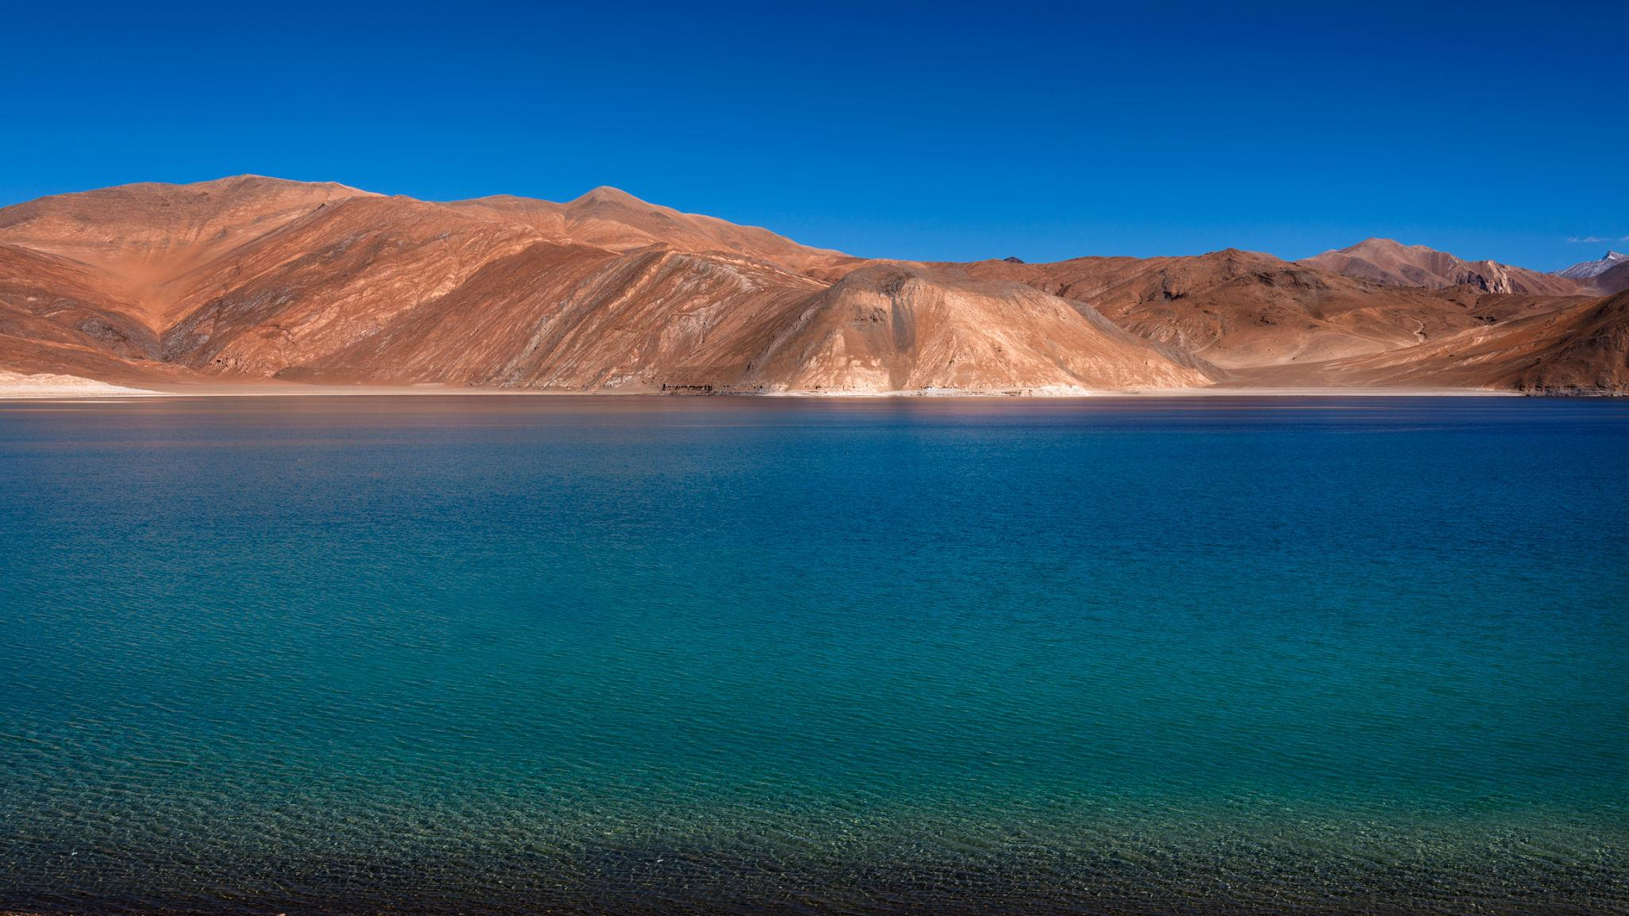
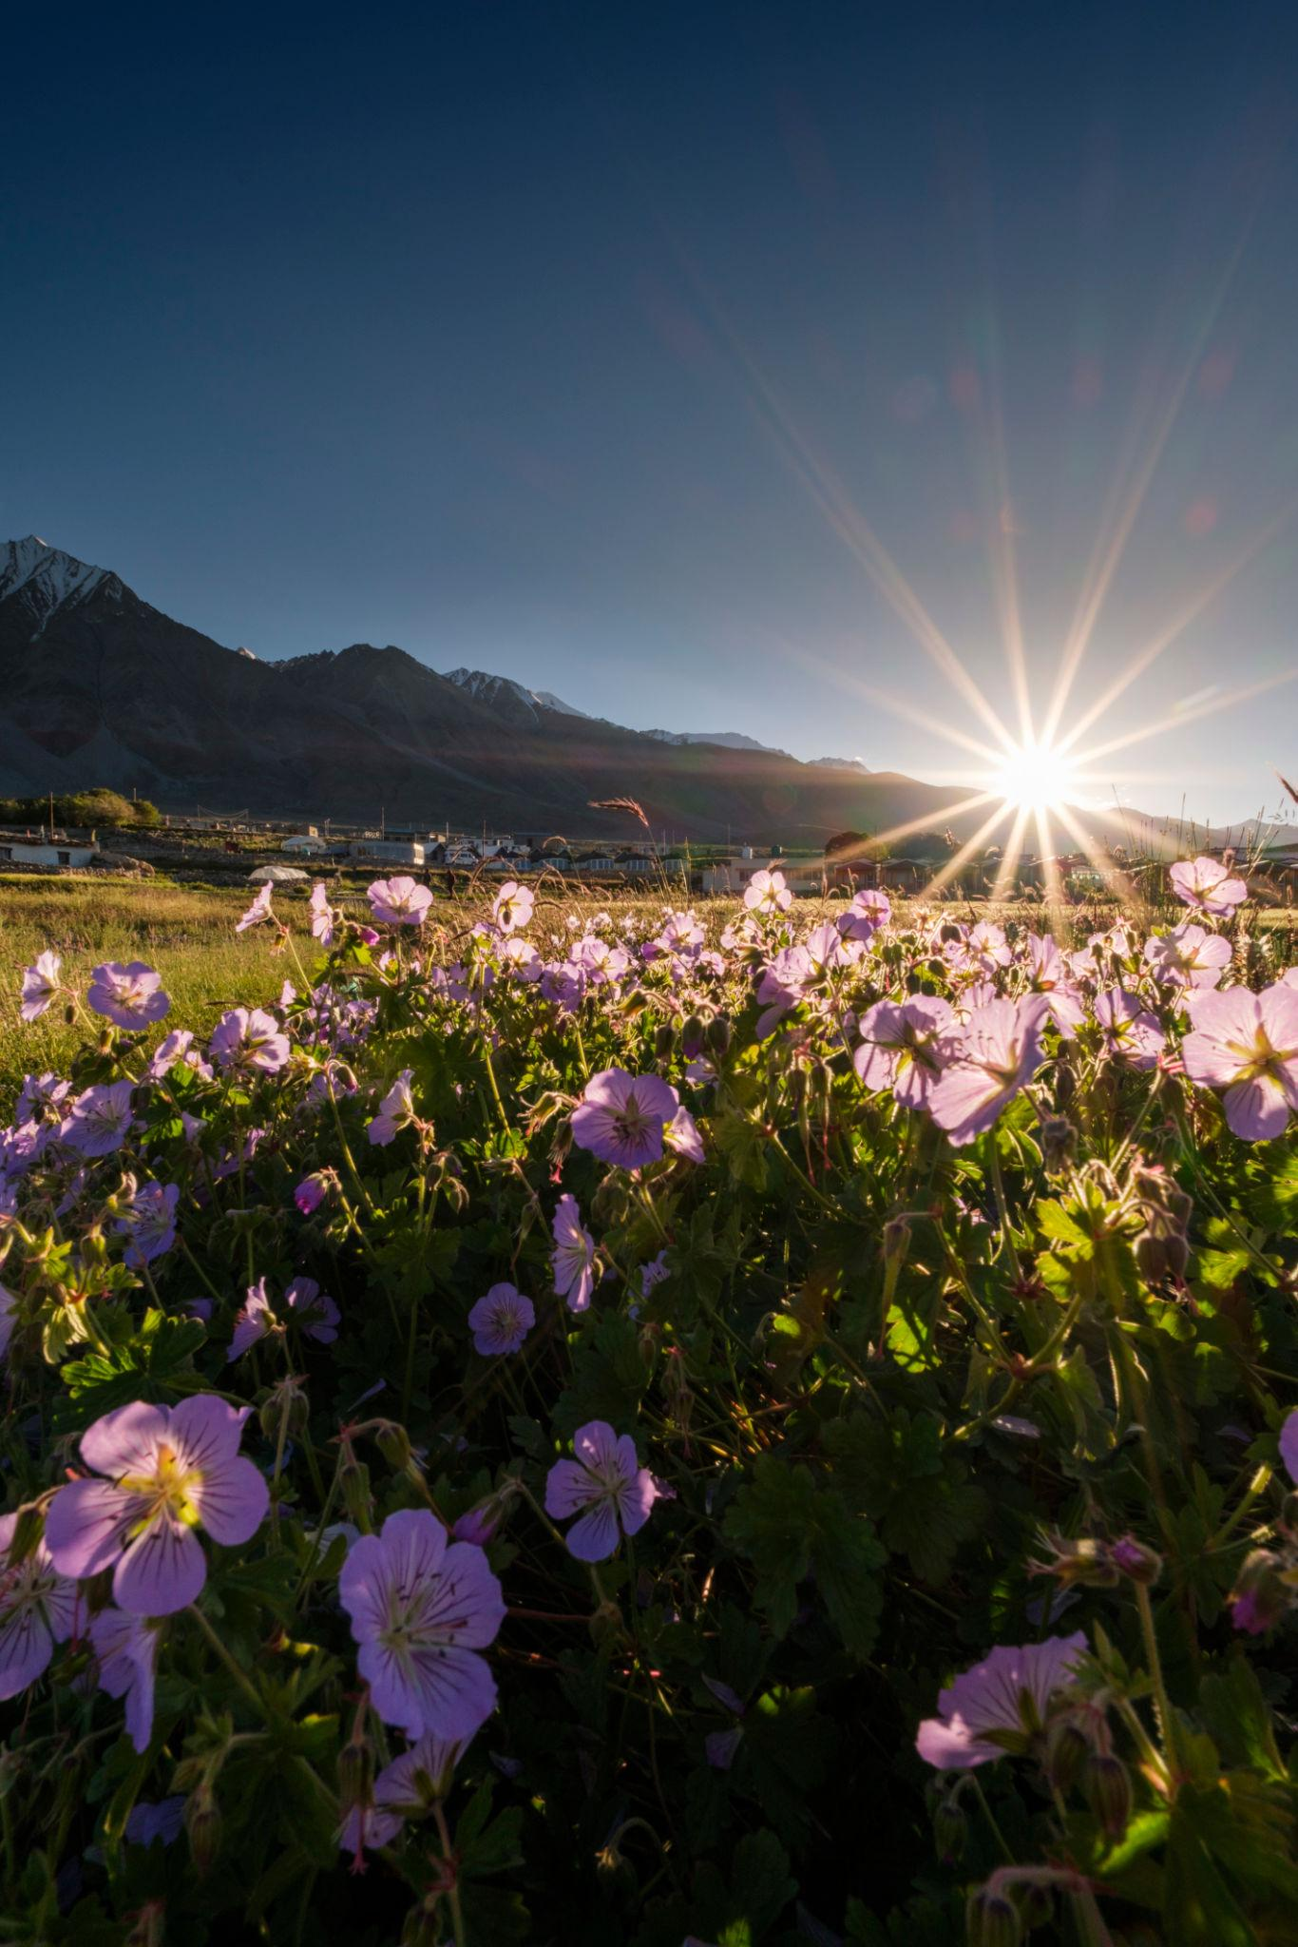
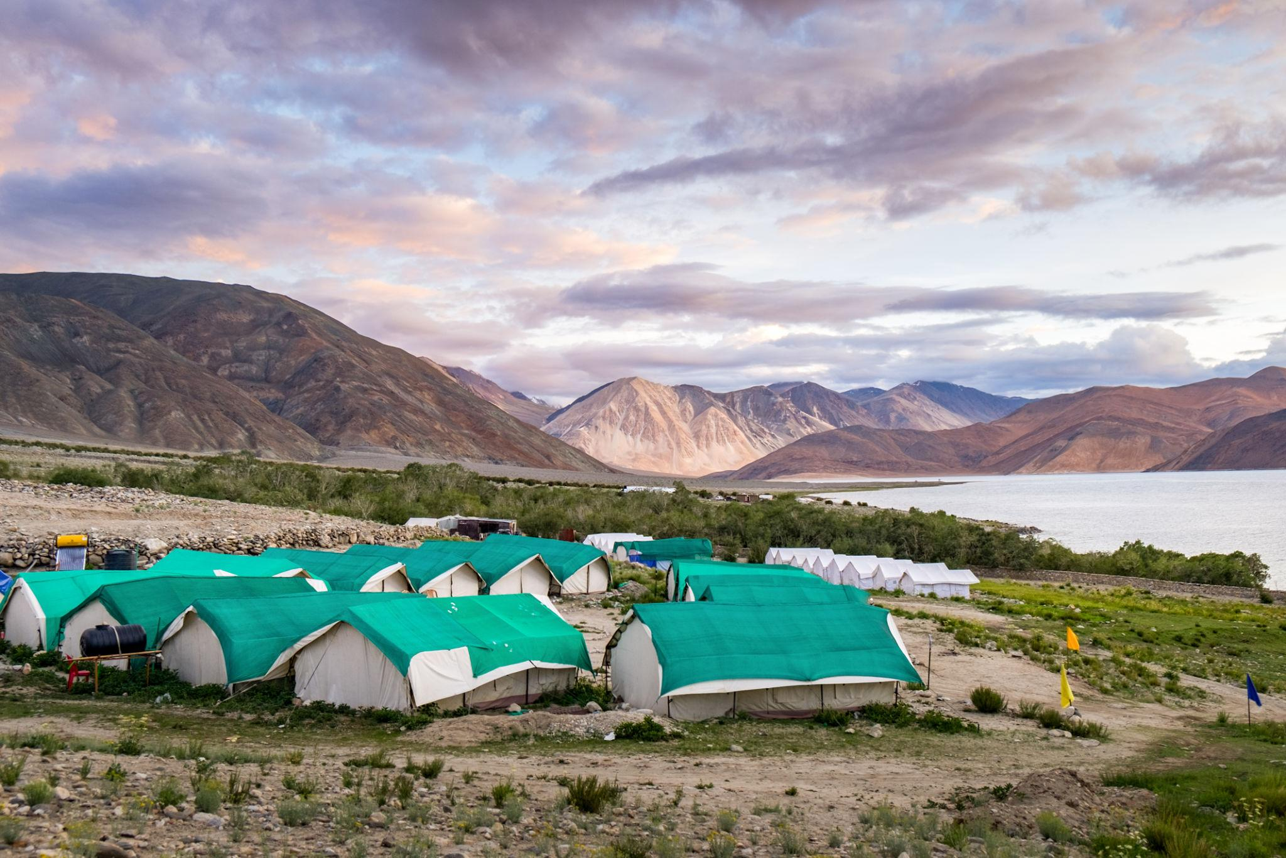
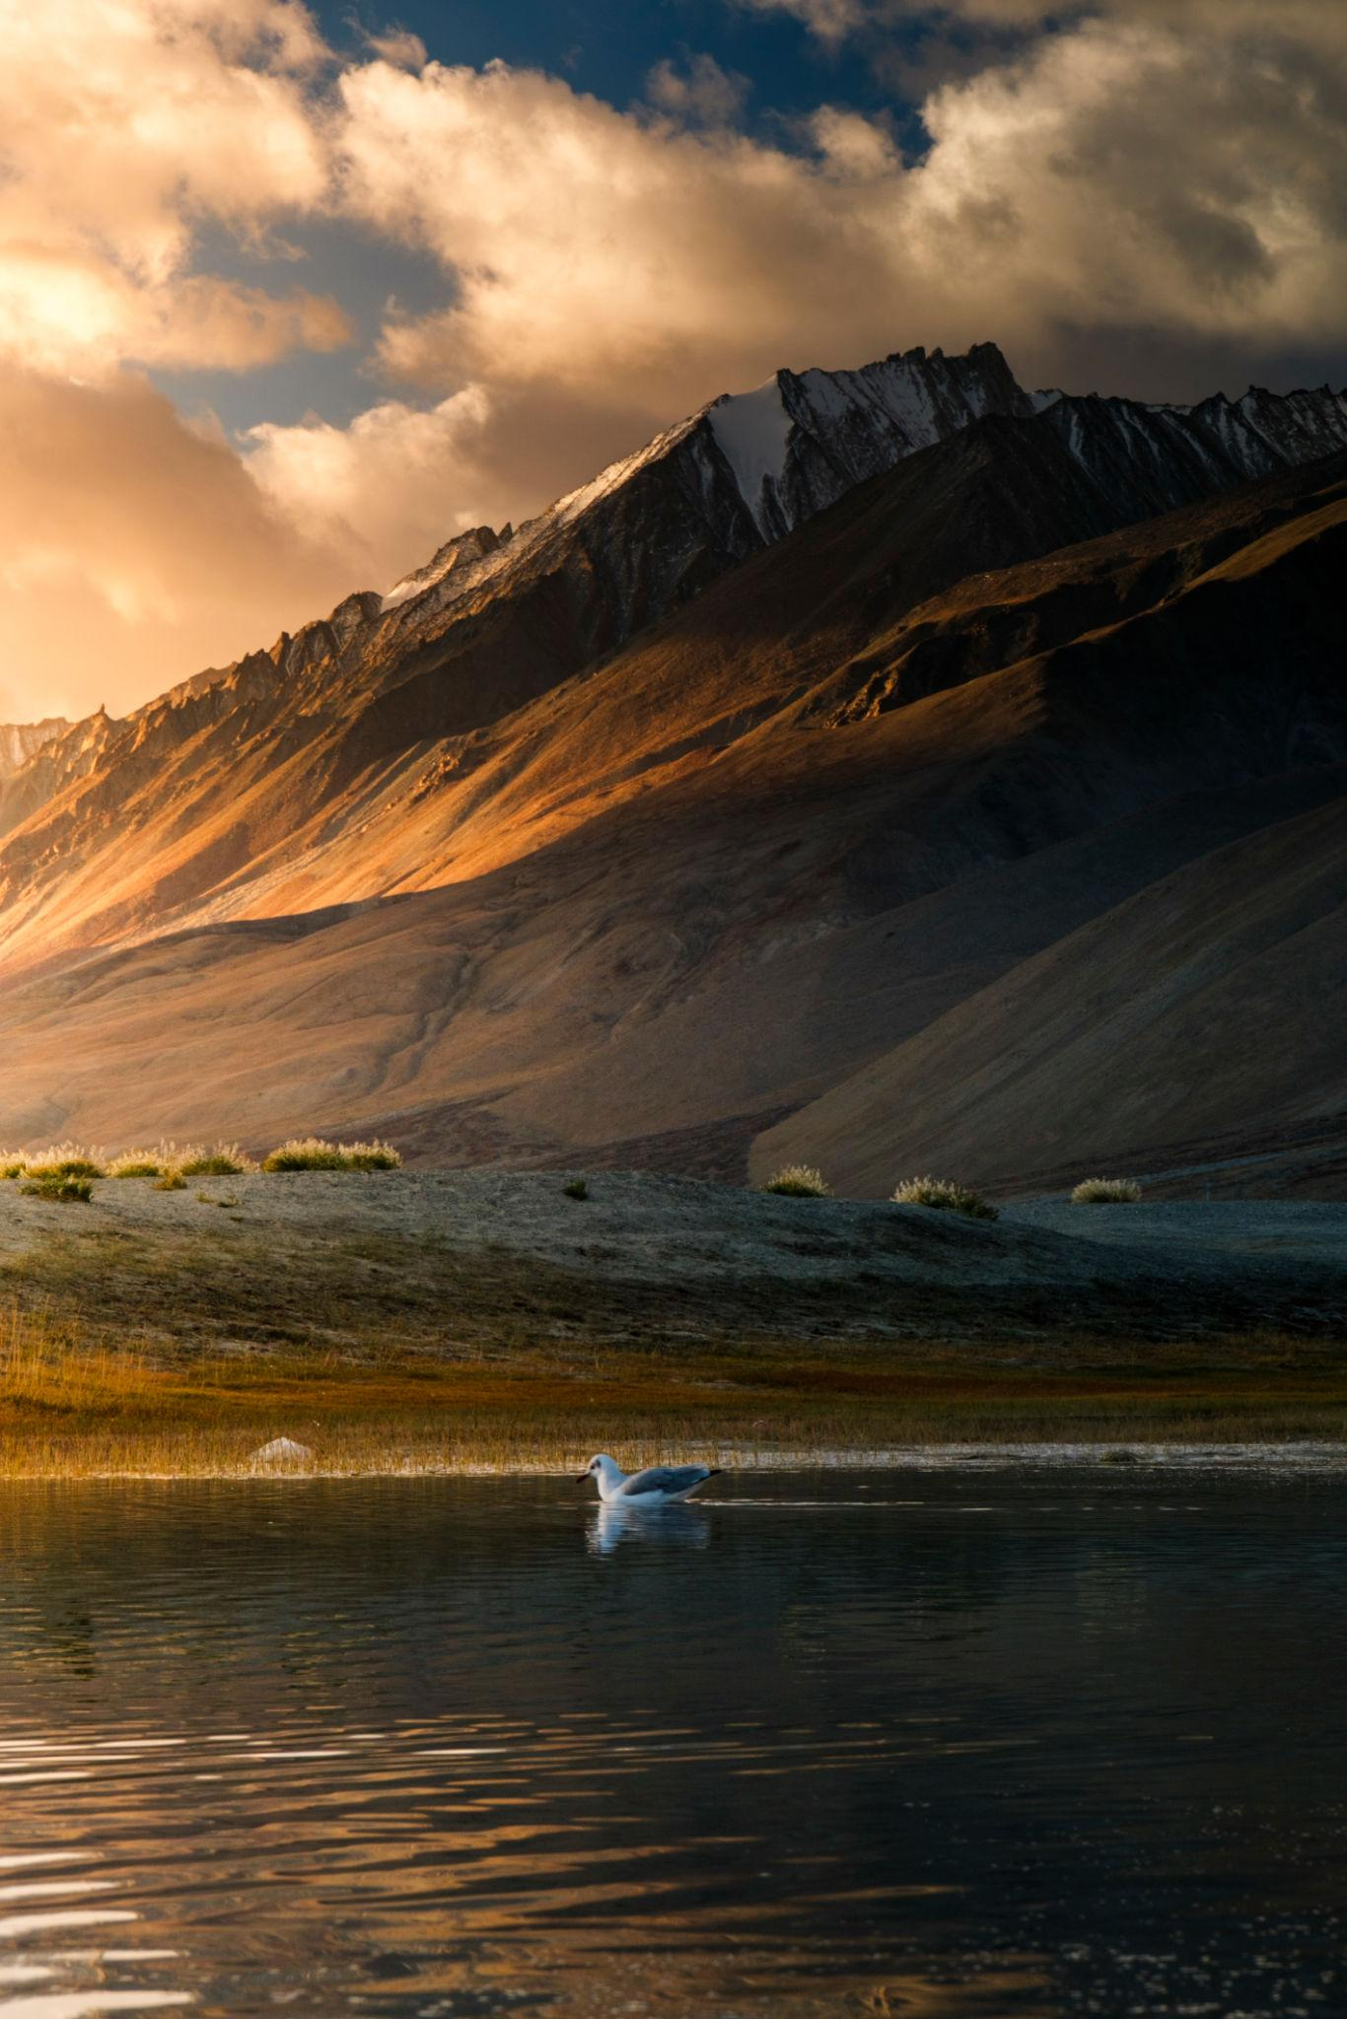
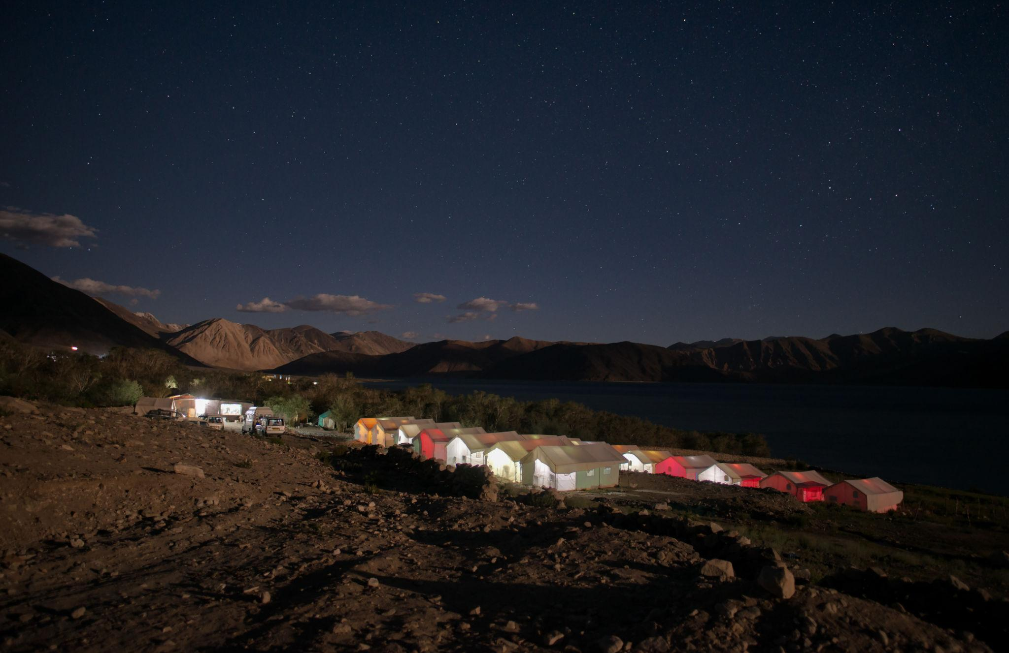
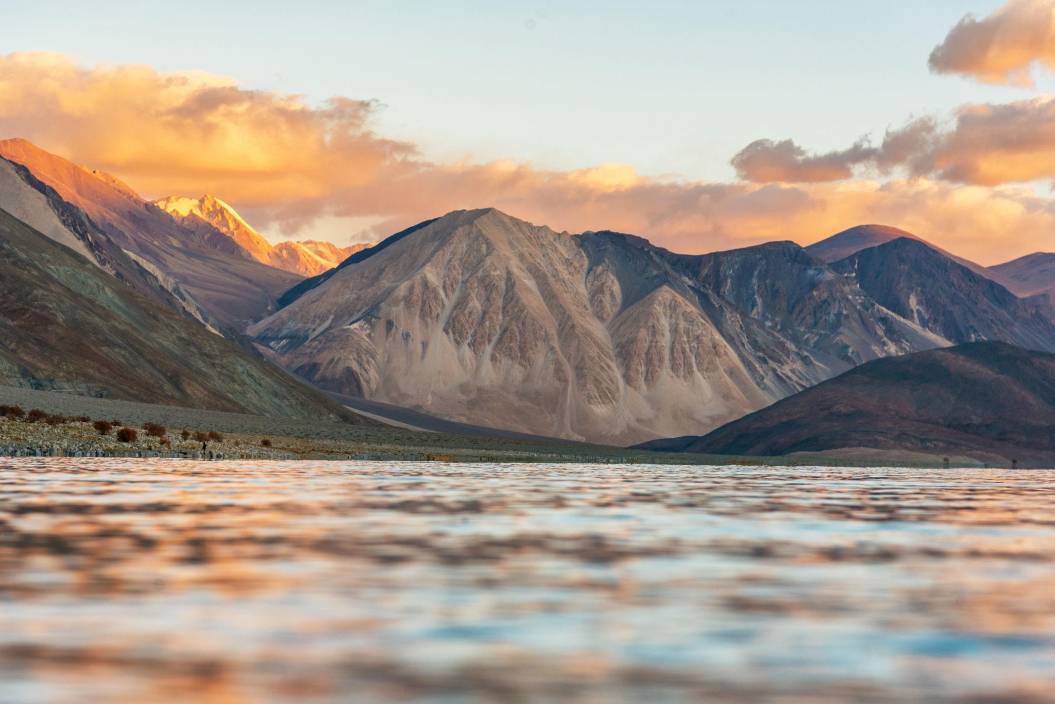

3. Nubra Valley
A stunning desert valley surrounded by snow-capped mountains.
Famous for:
- Sand dunes
- Double-humped camels
- Scenic drives
- Riverside camps
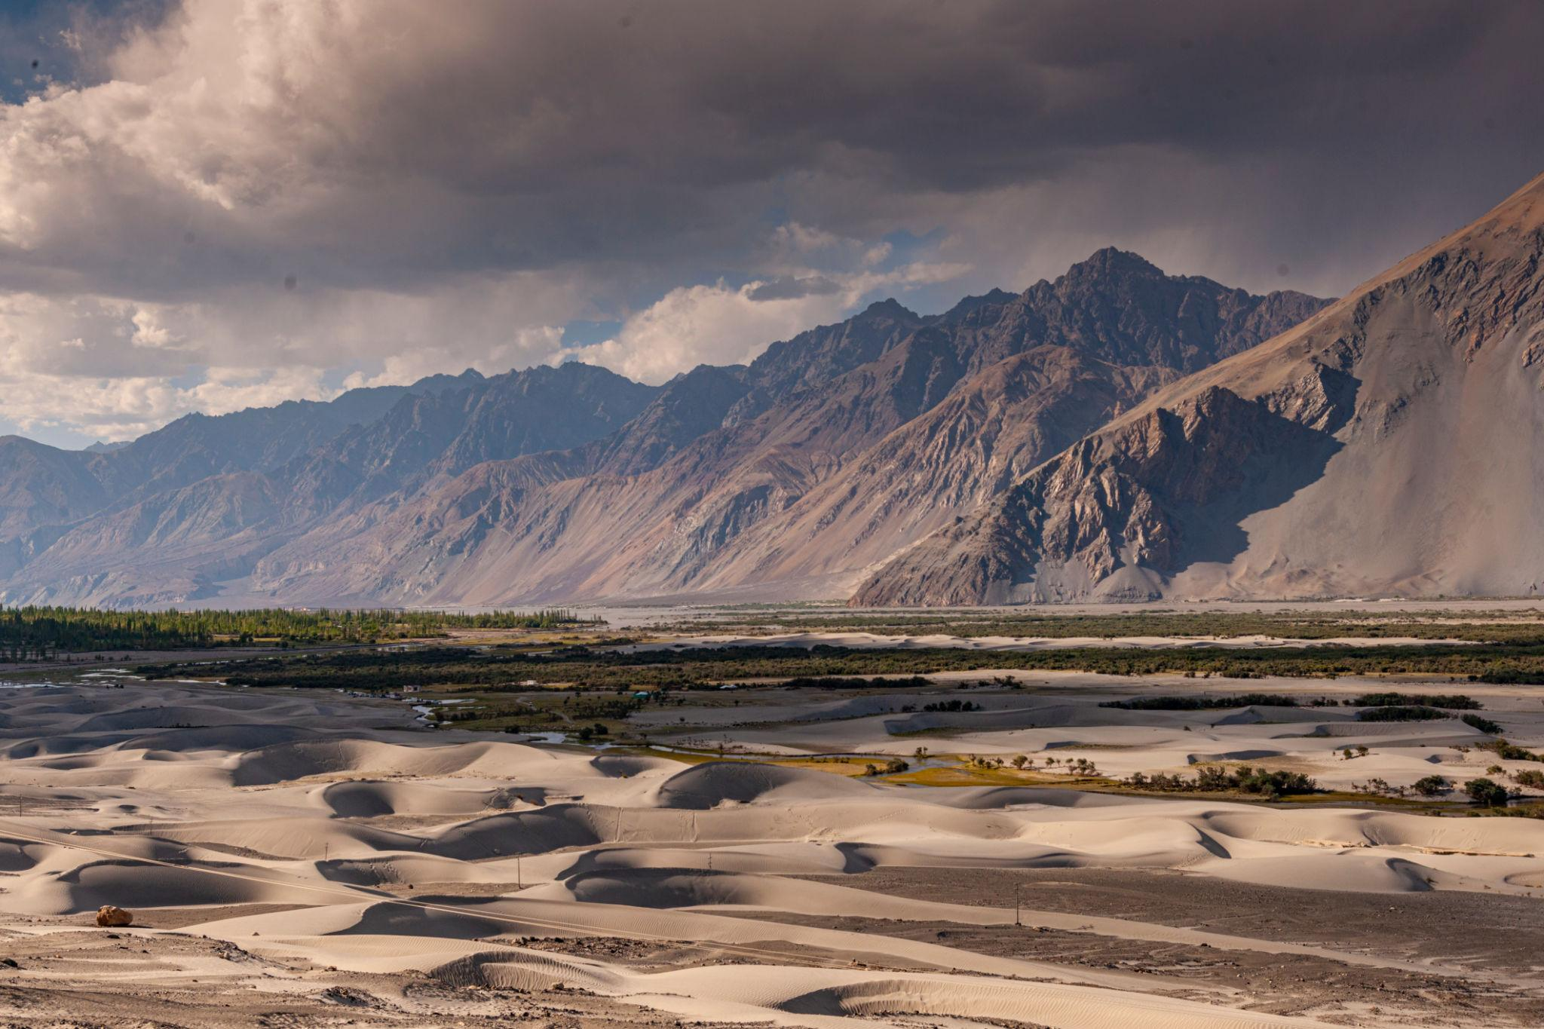
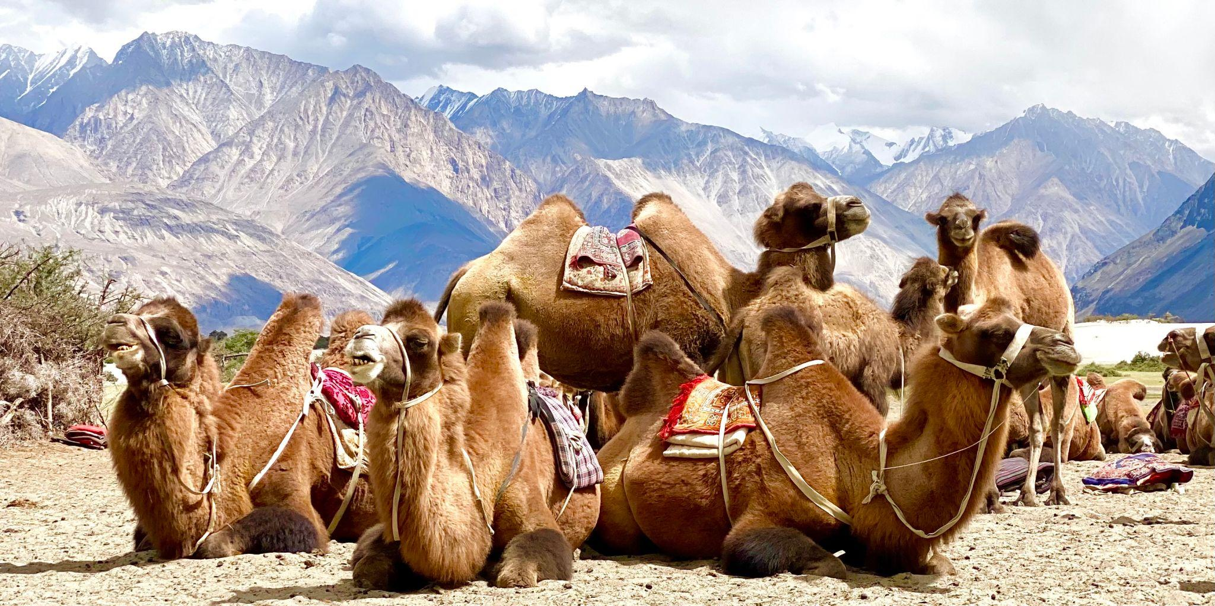
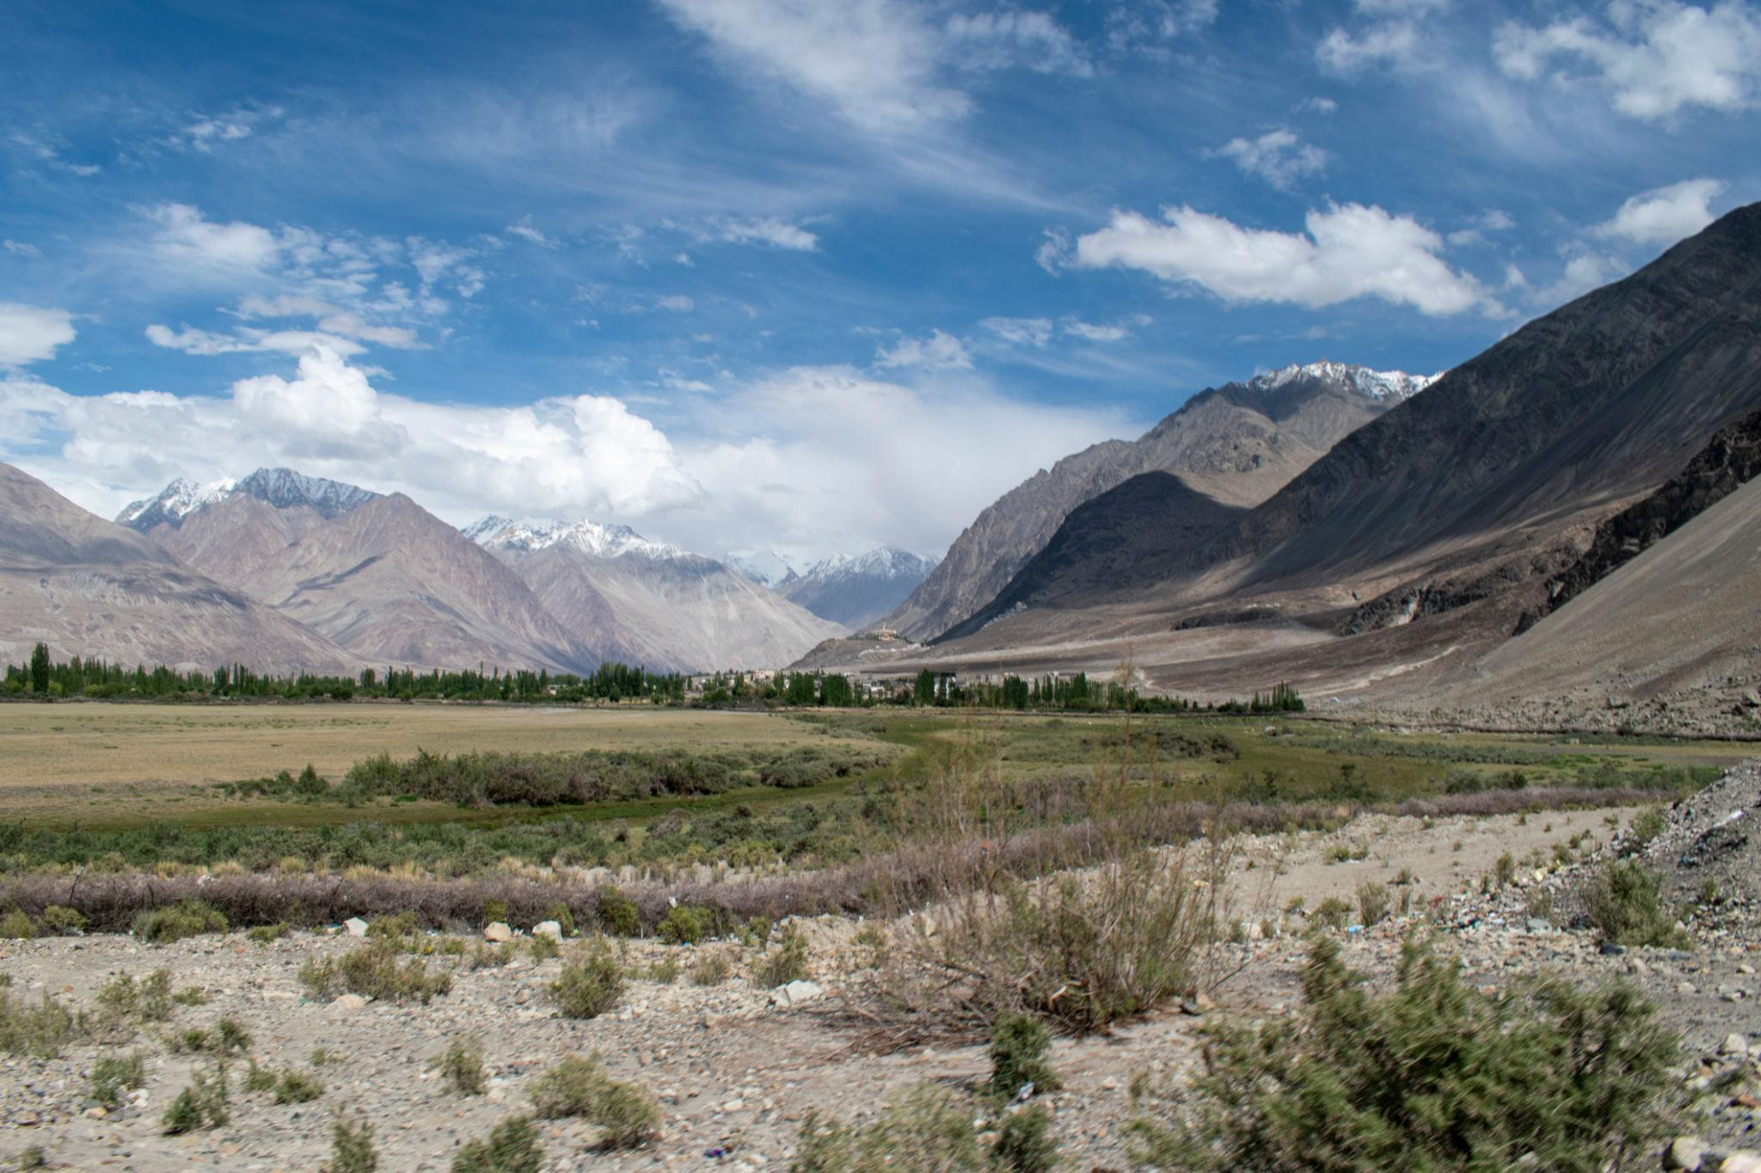
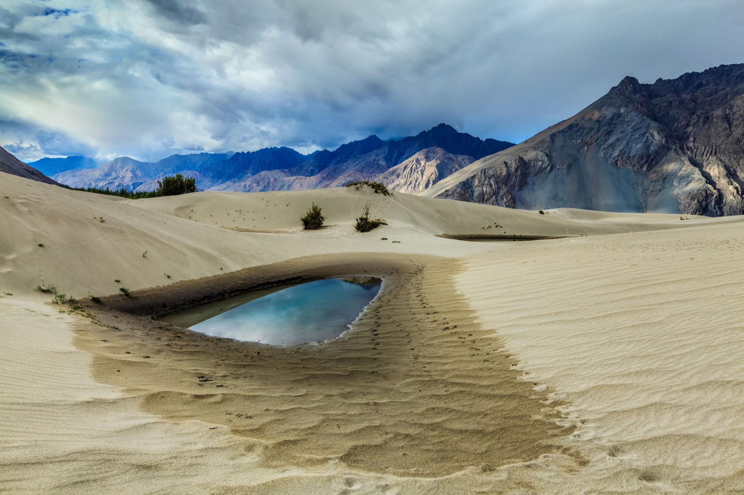
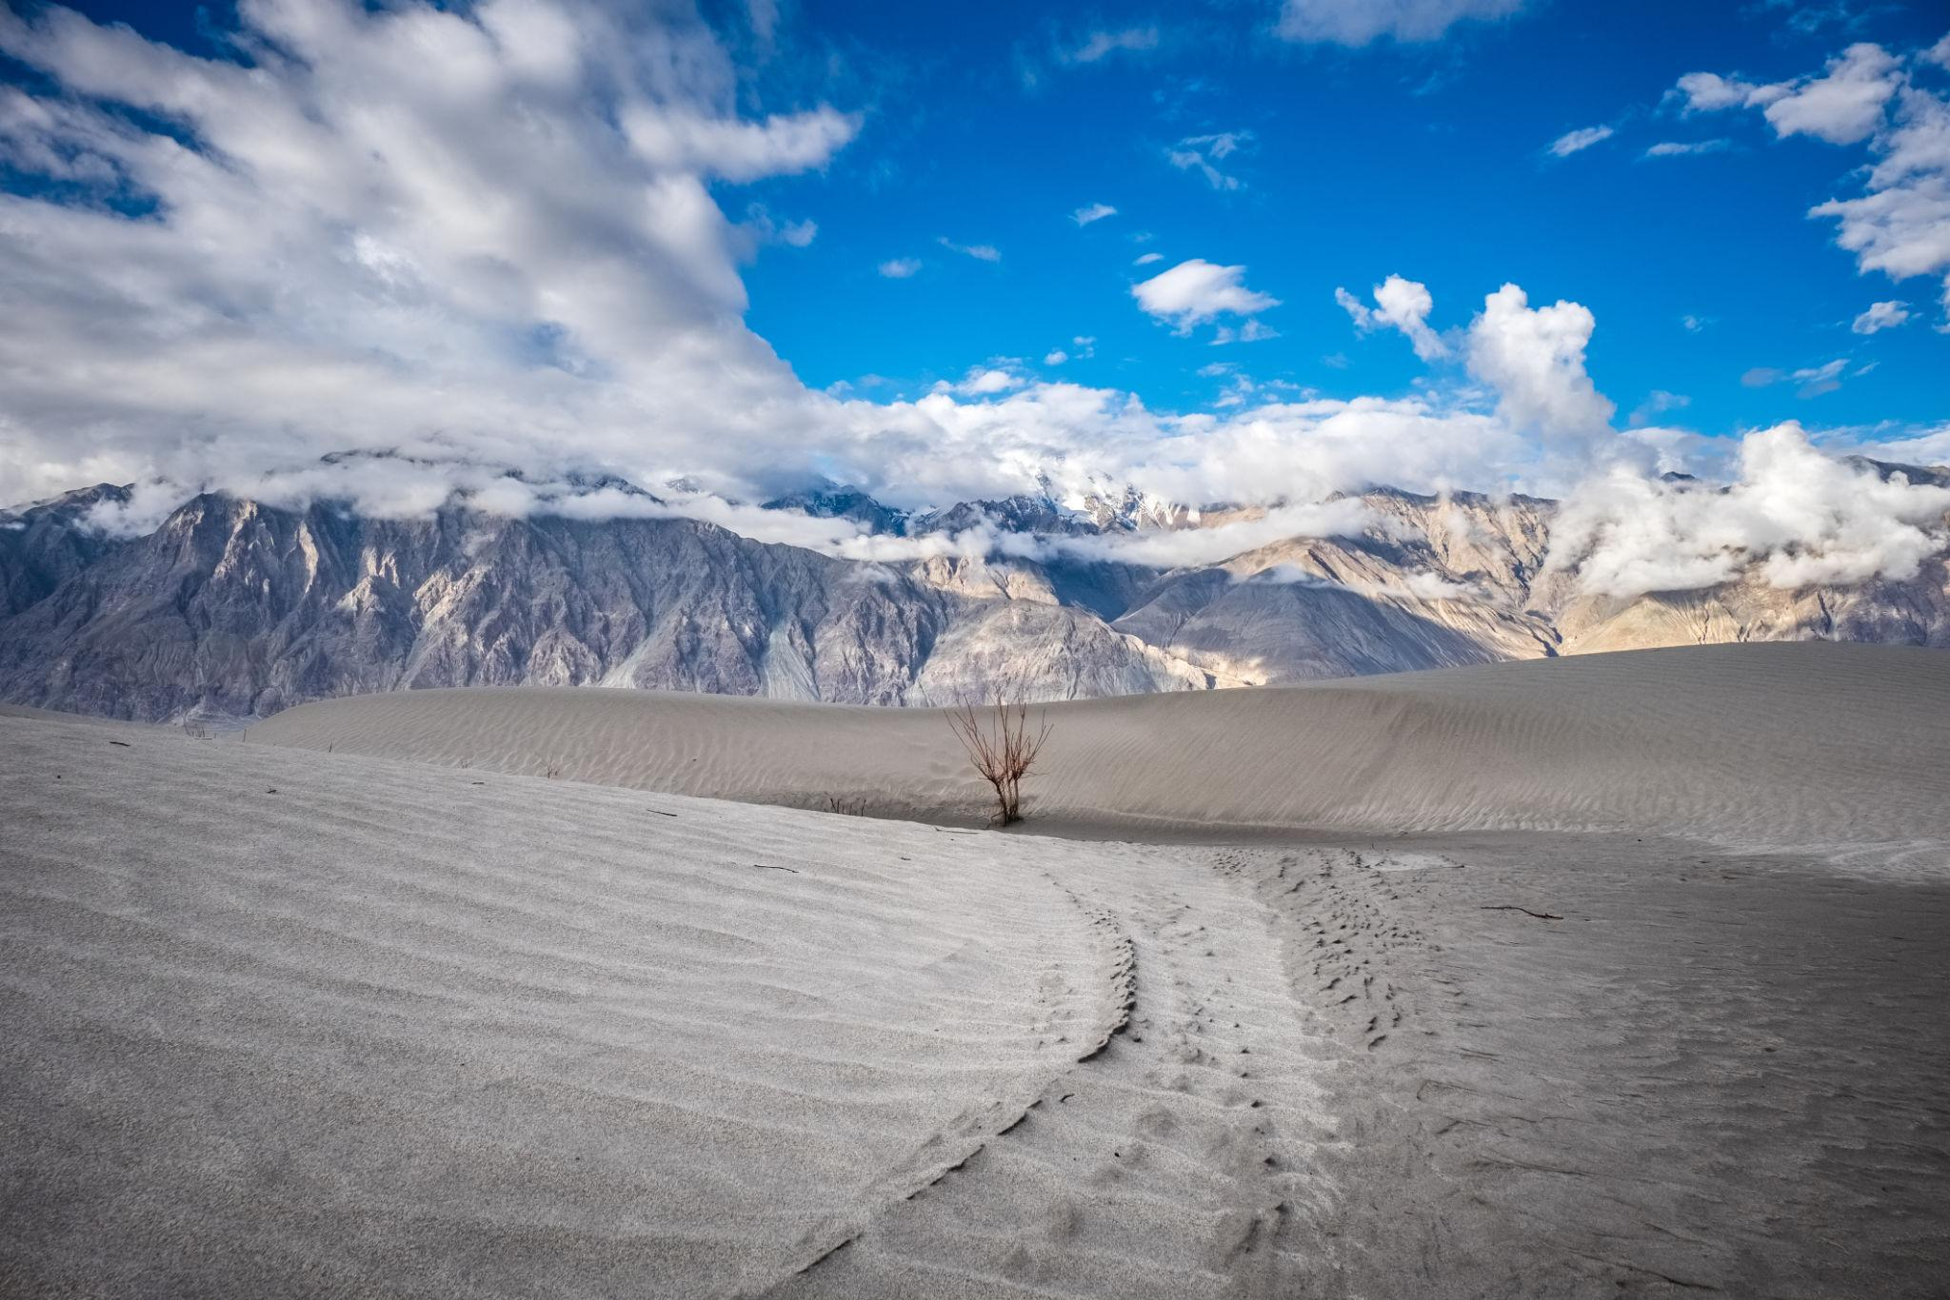
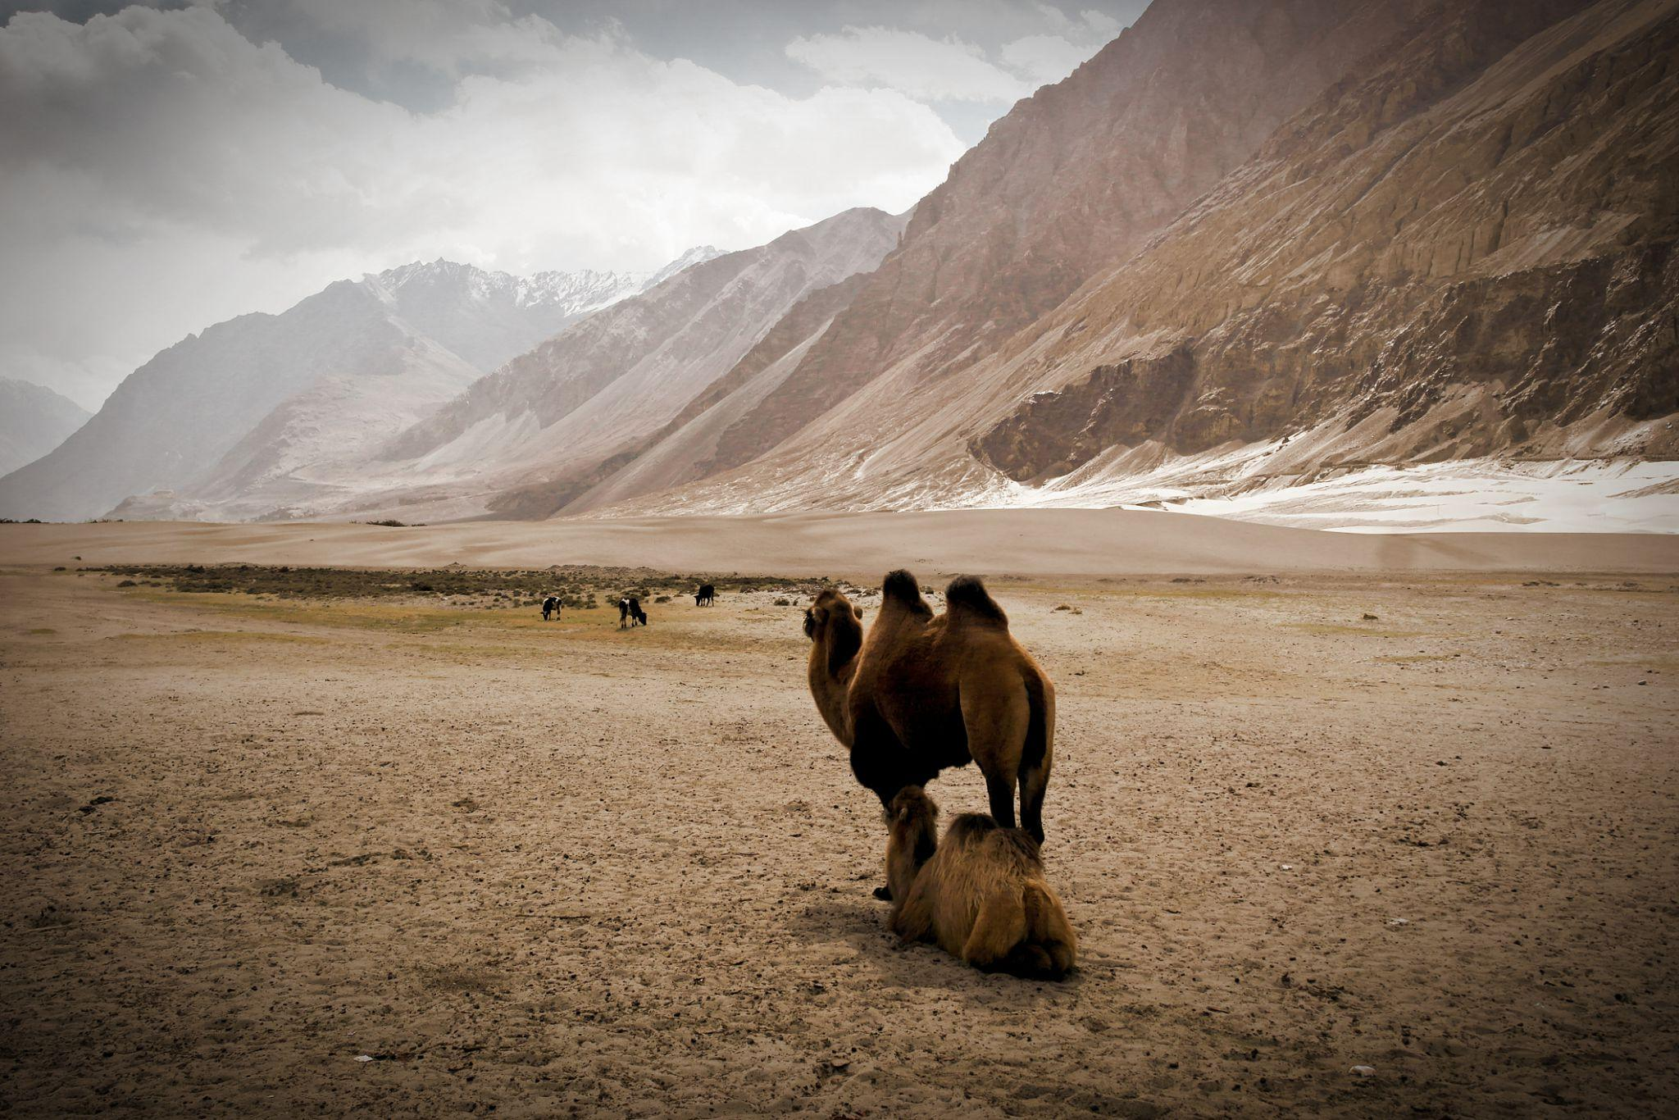
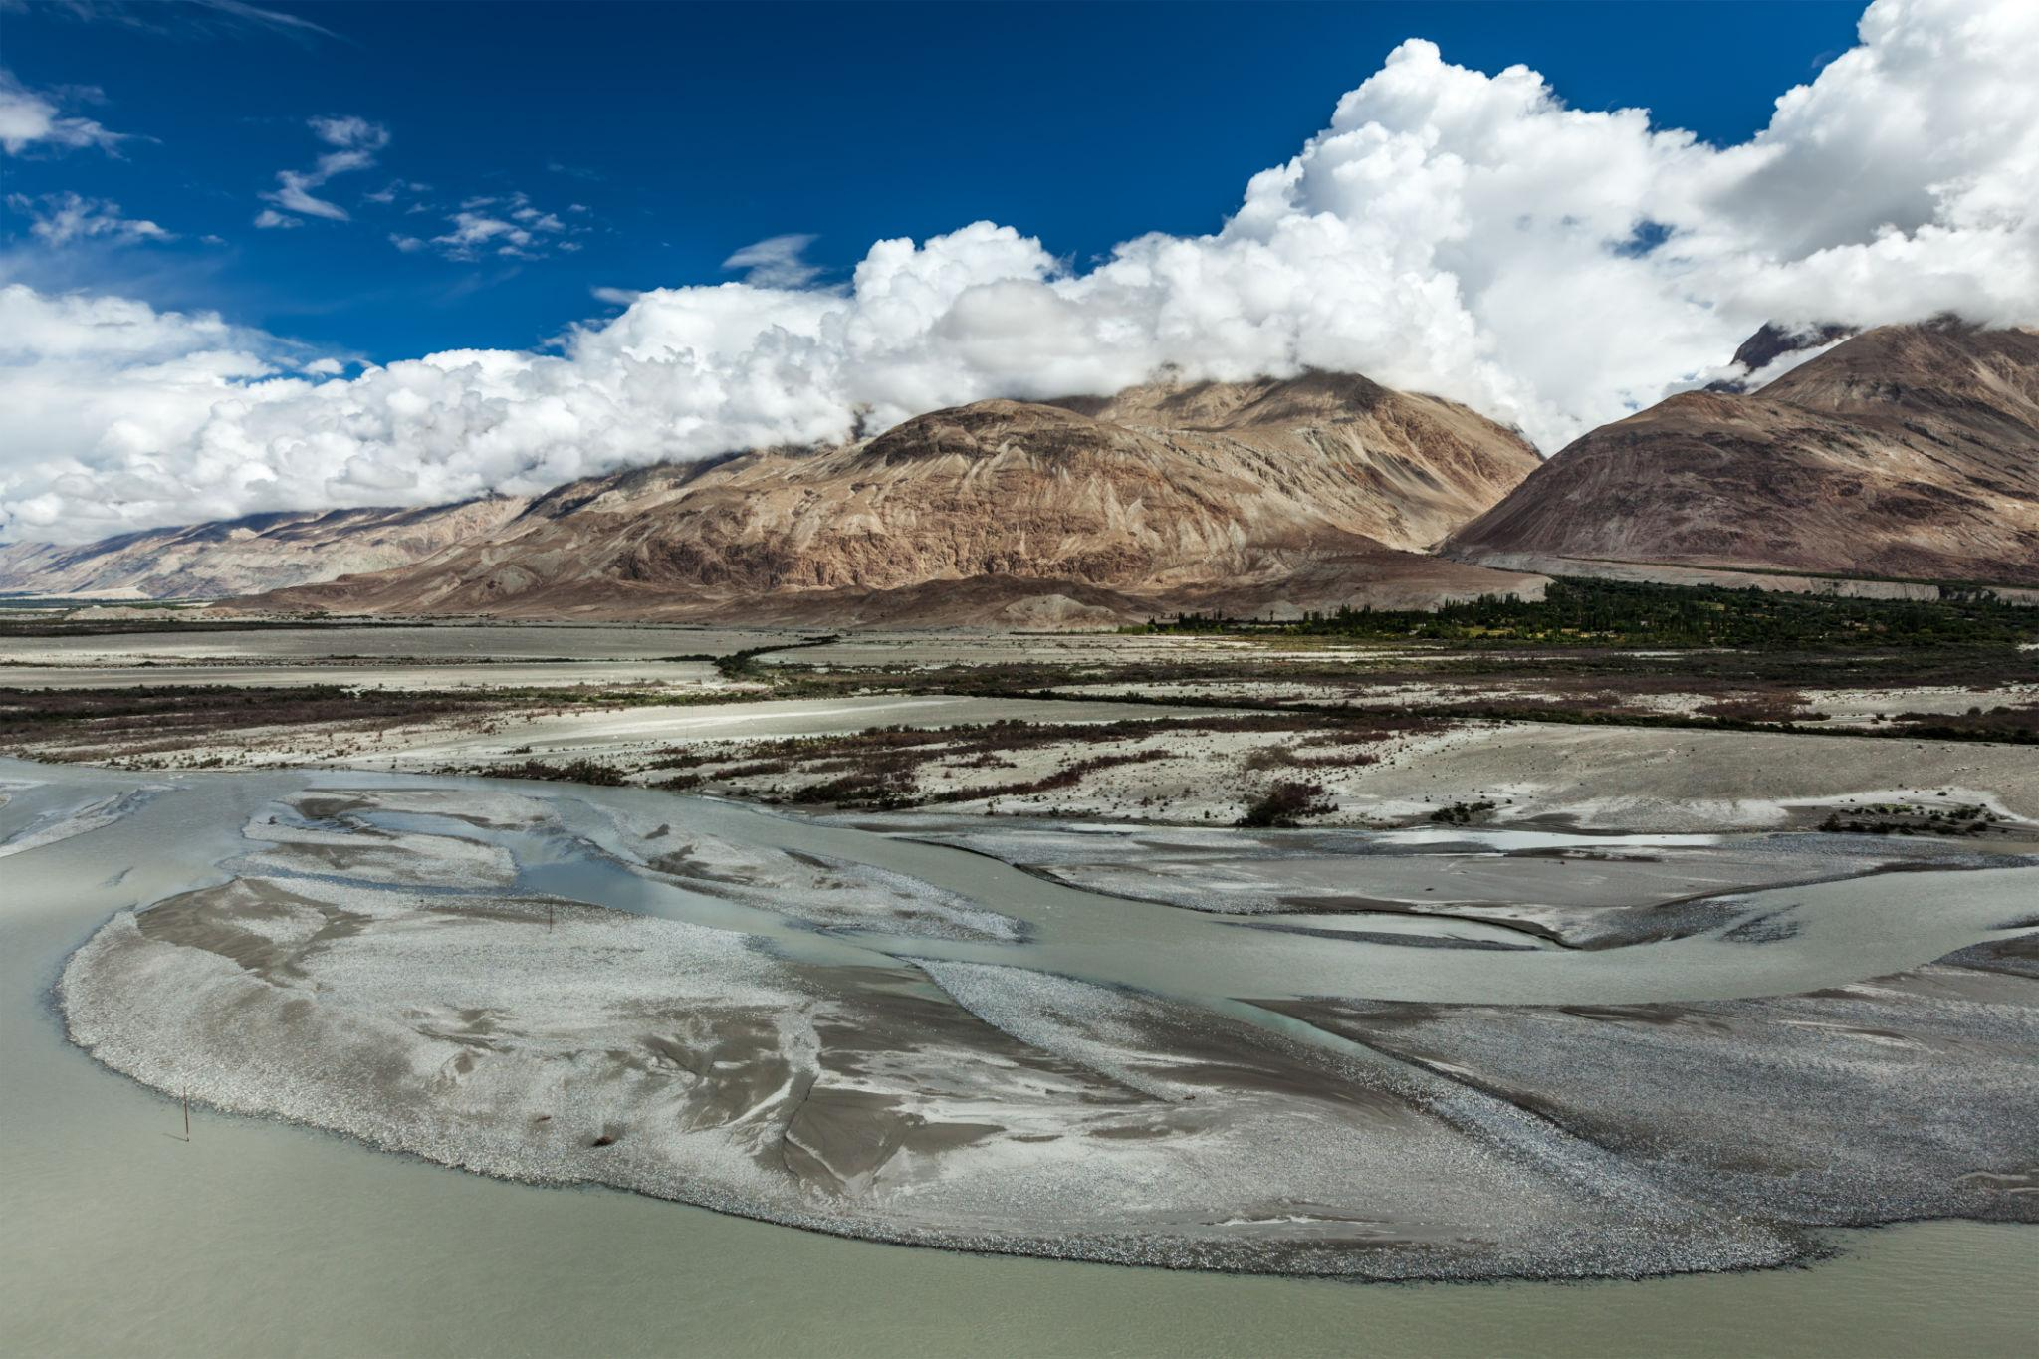
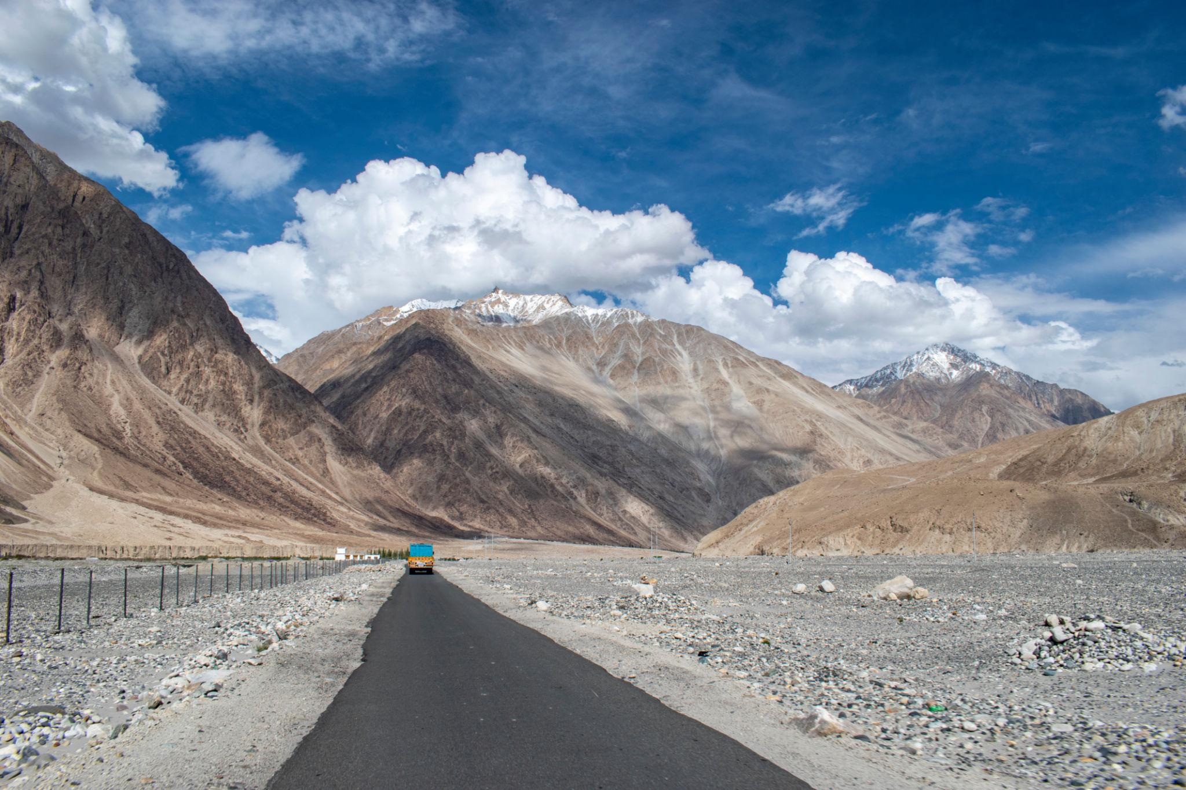

4. Khardung La Pass
One of the world’s highest motorable roads.
Best for:
- Adventure road trips
- Biking experiences
- Snow views
- Mountain photography
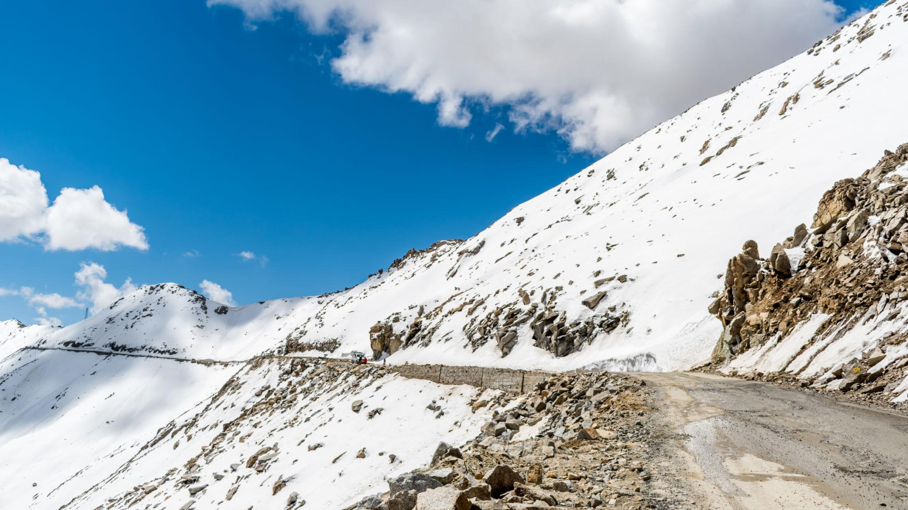
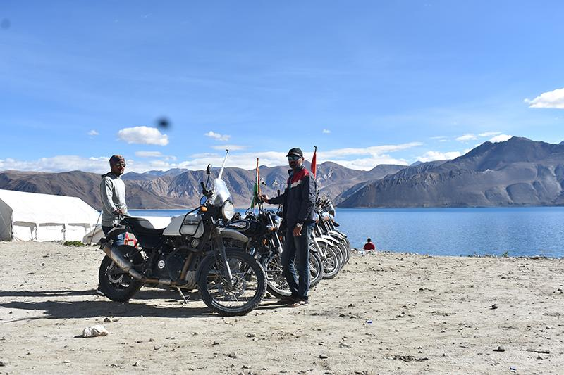
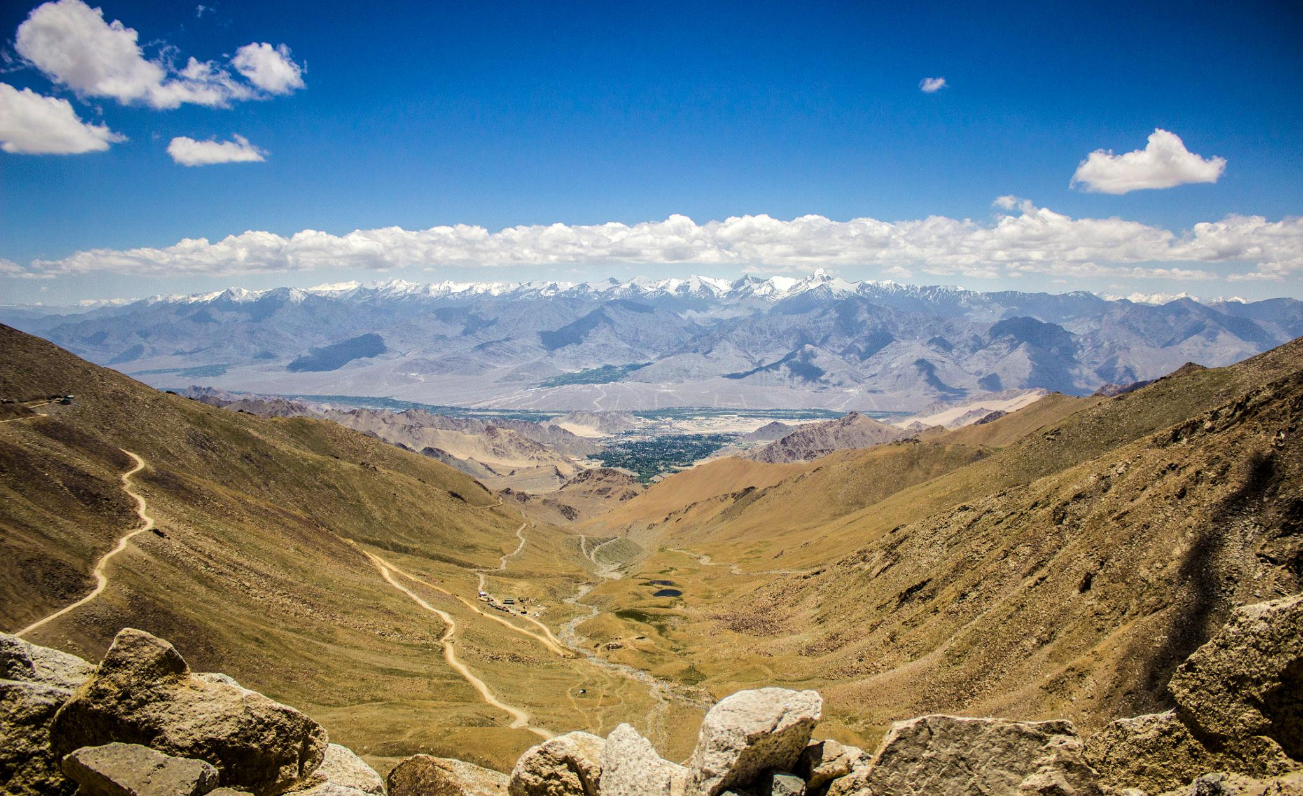
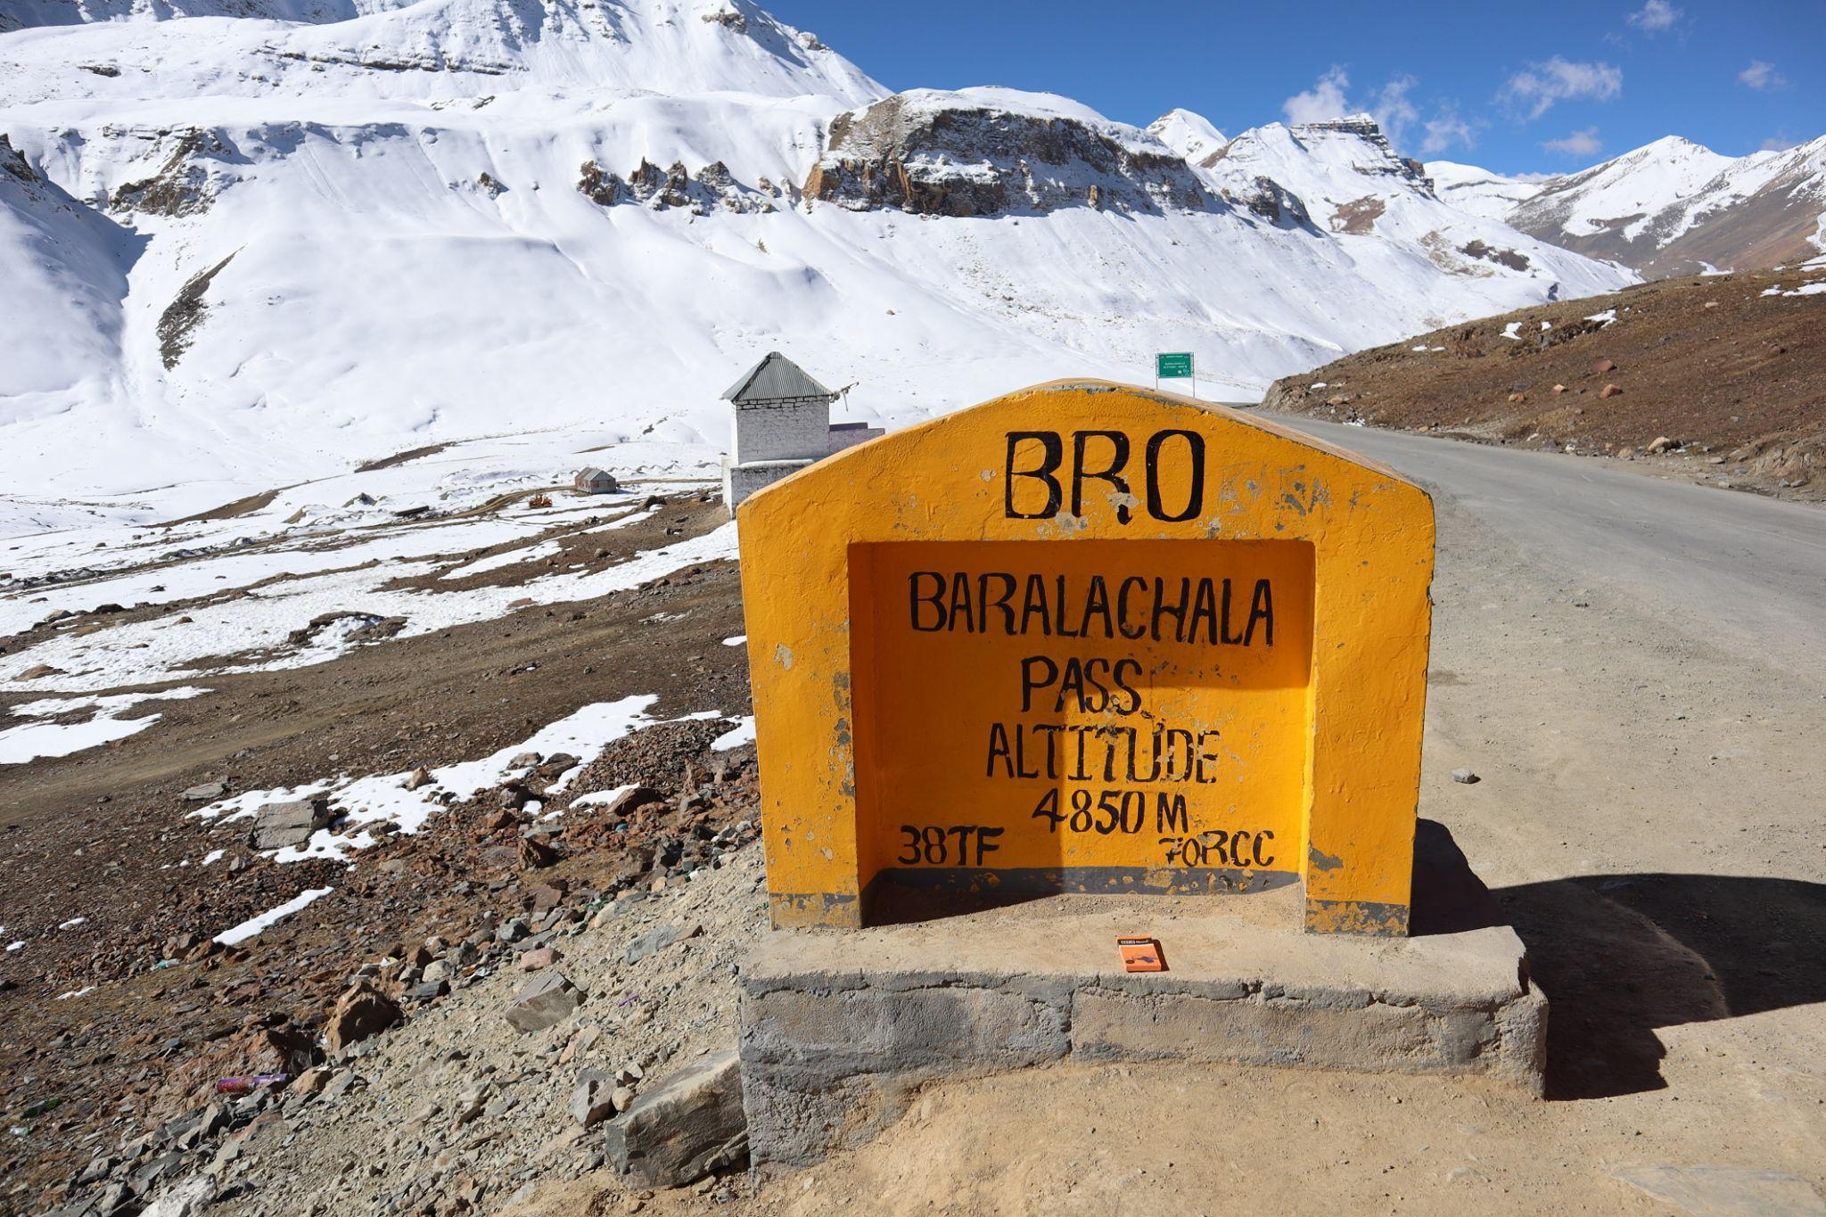
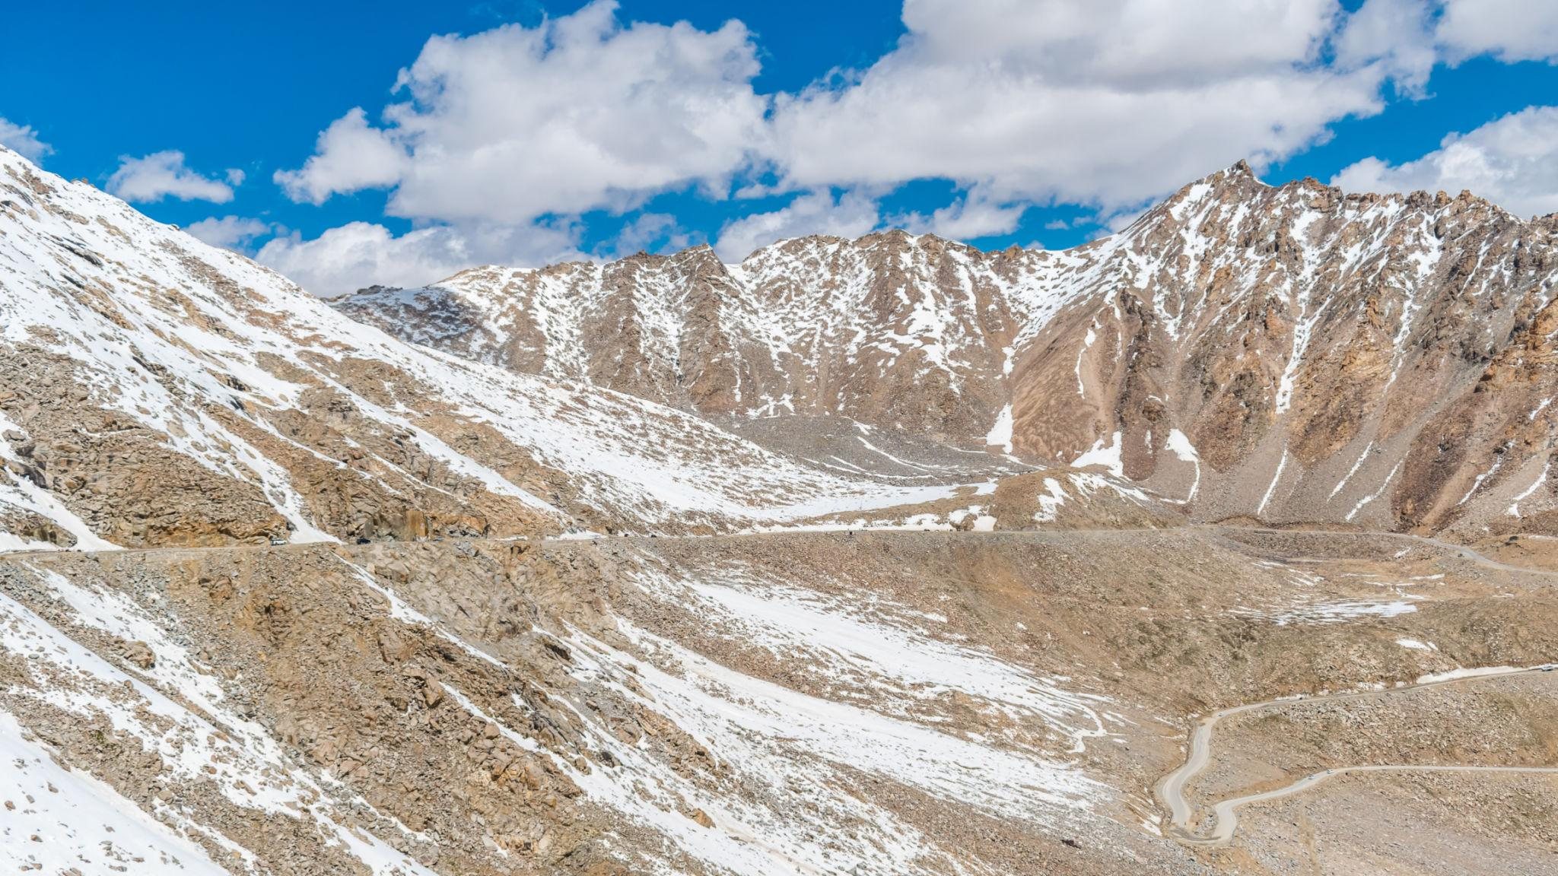
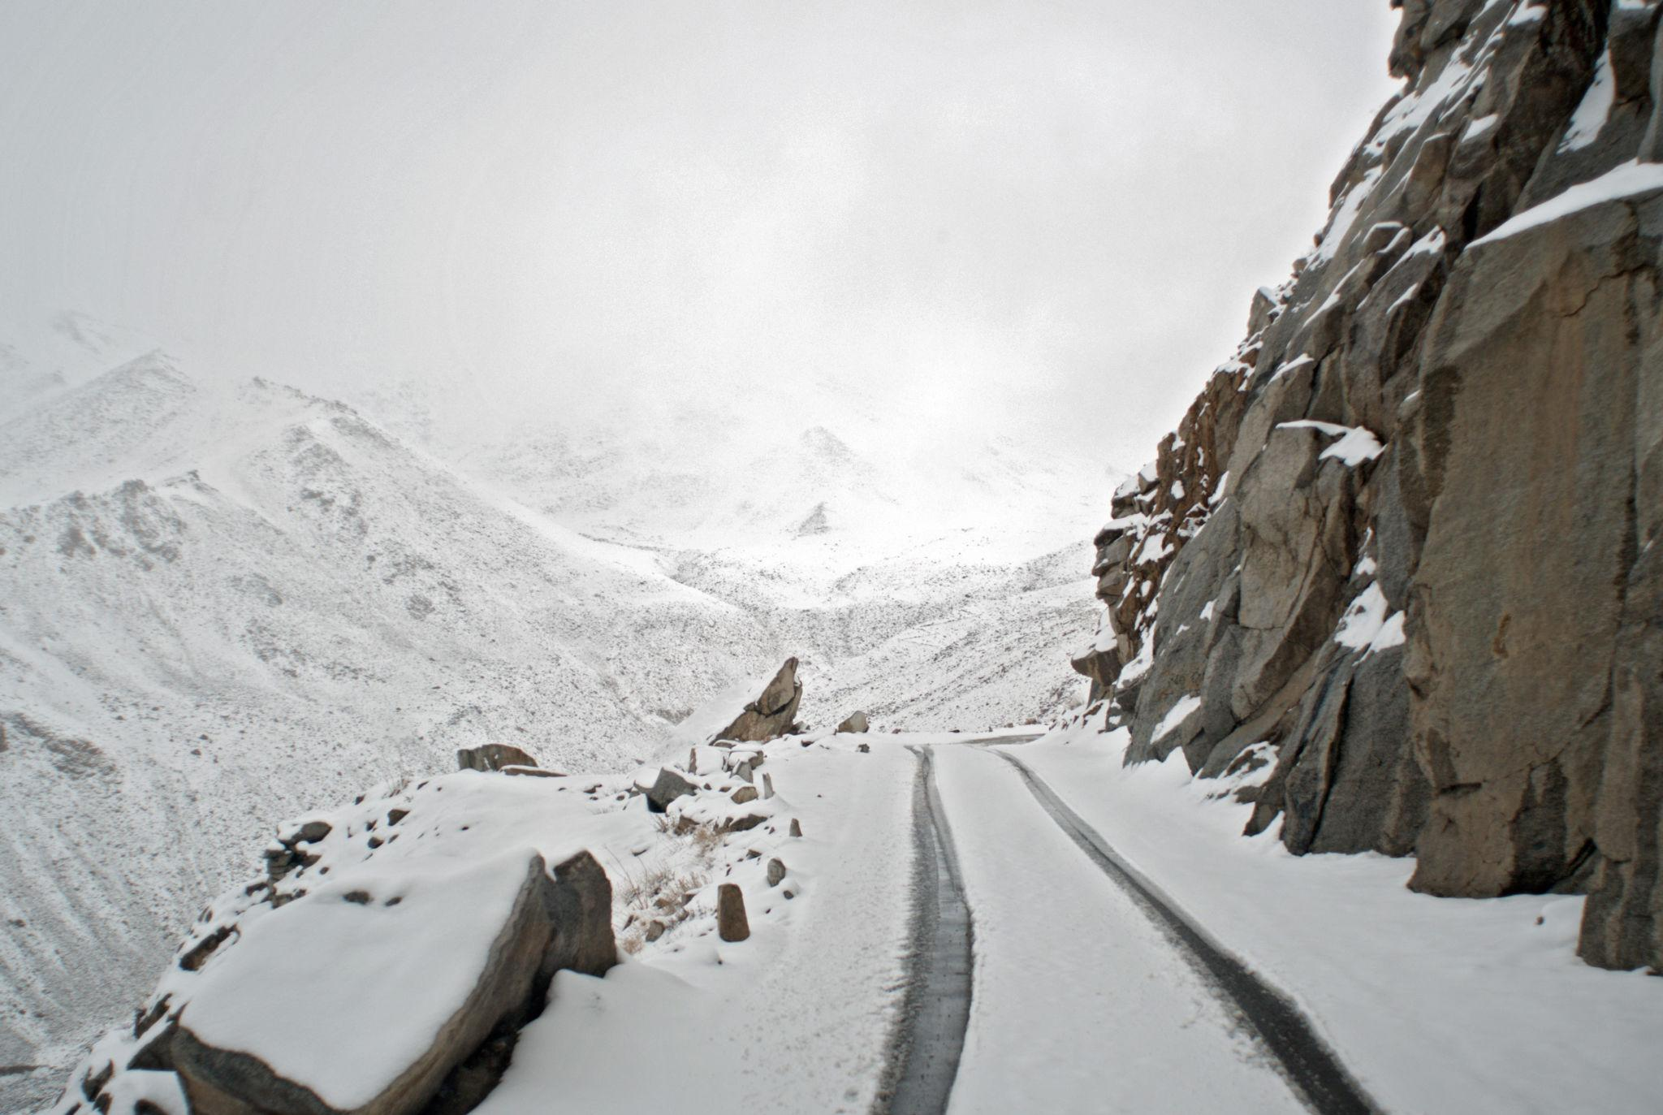

5. Magnetic Hill
A mysterious gravity-defying phenomenon and popular tourist attraction.
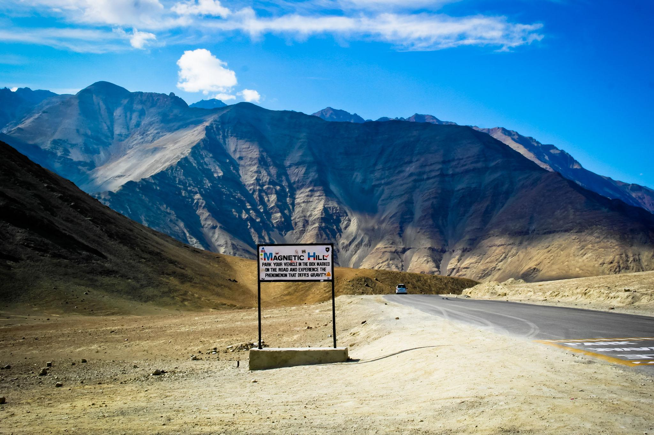
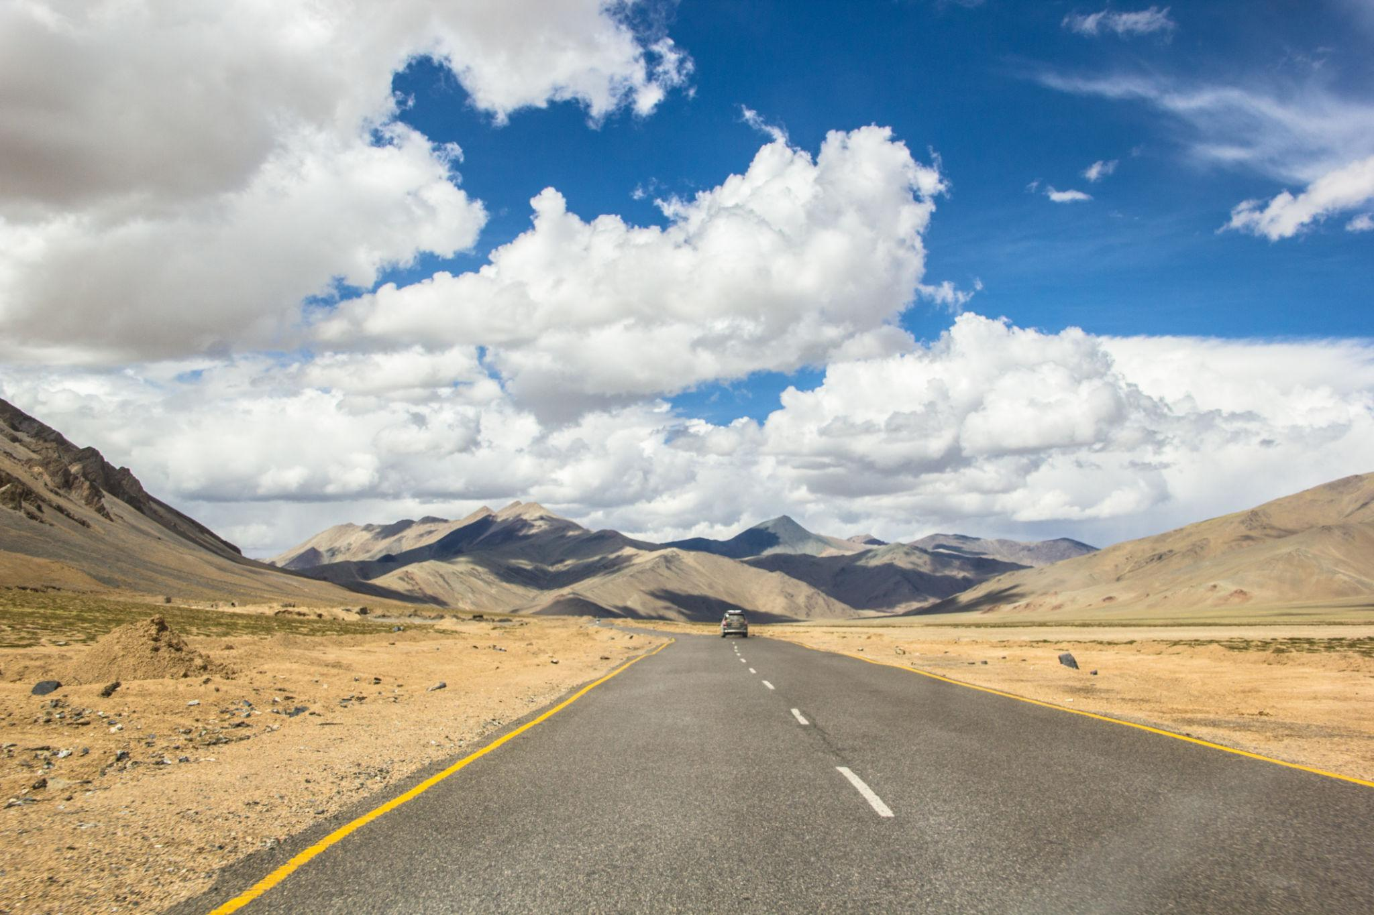
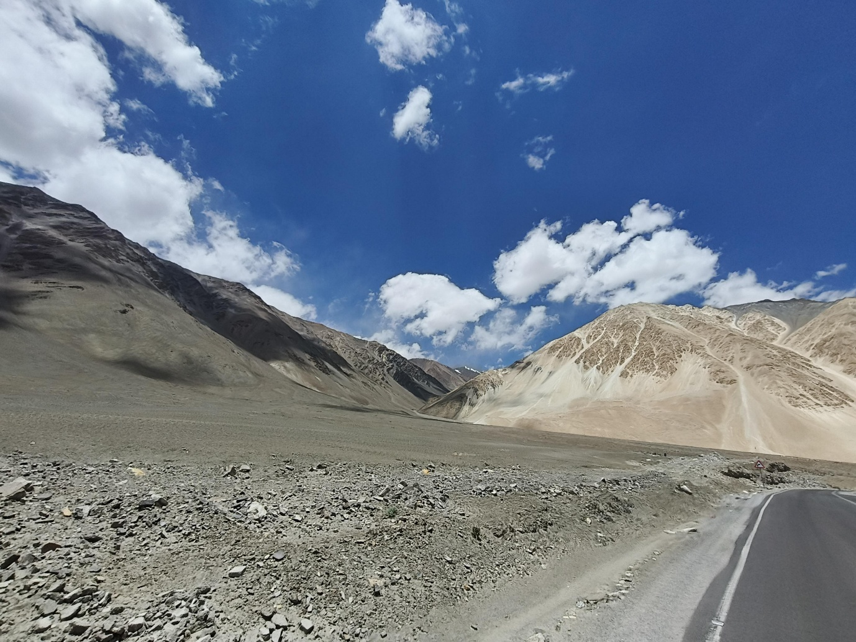
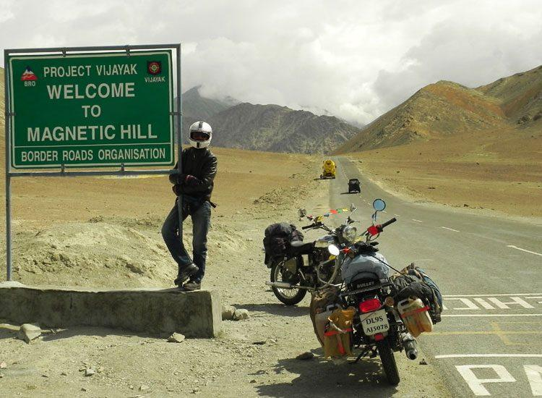
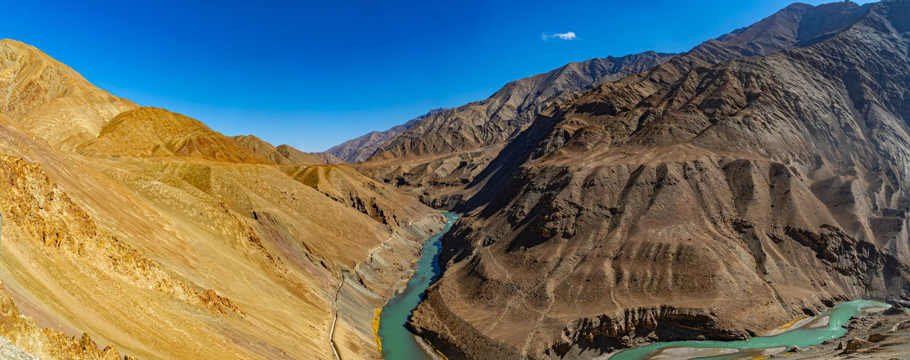
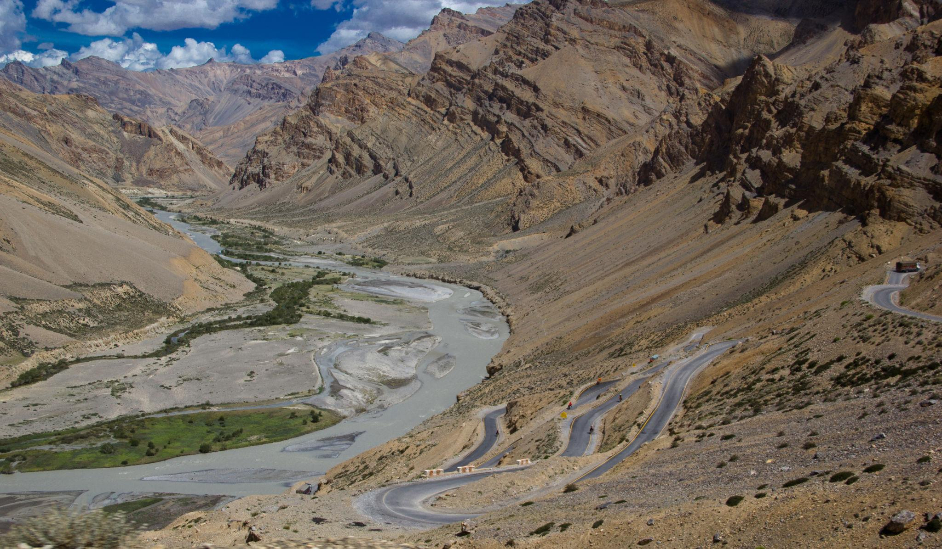

6. Thiksey Monastery
A beautiful Tibetan Buddhist monastery known for spiritual atmosphere and mountain views.
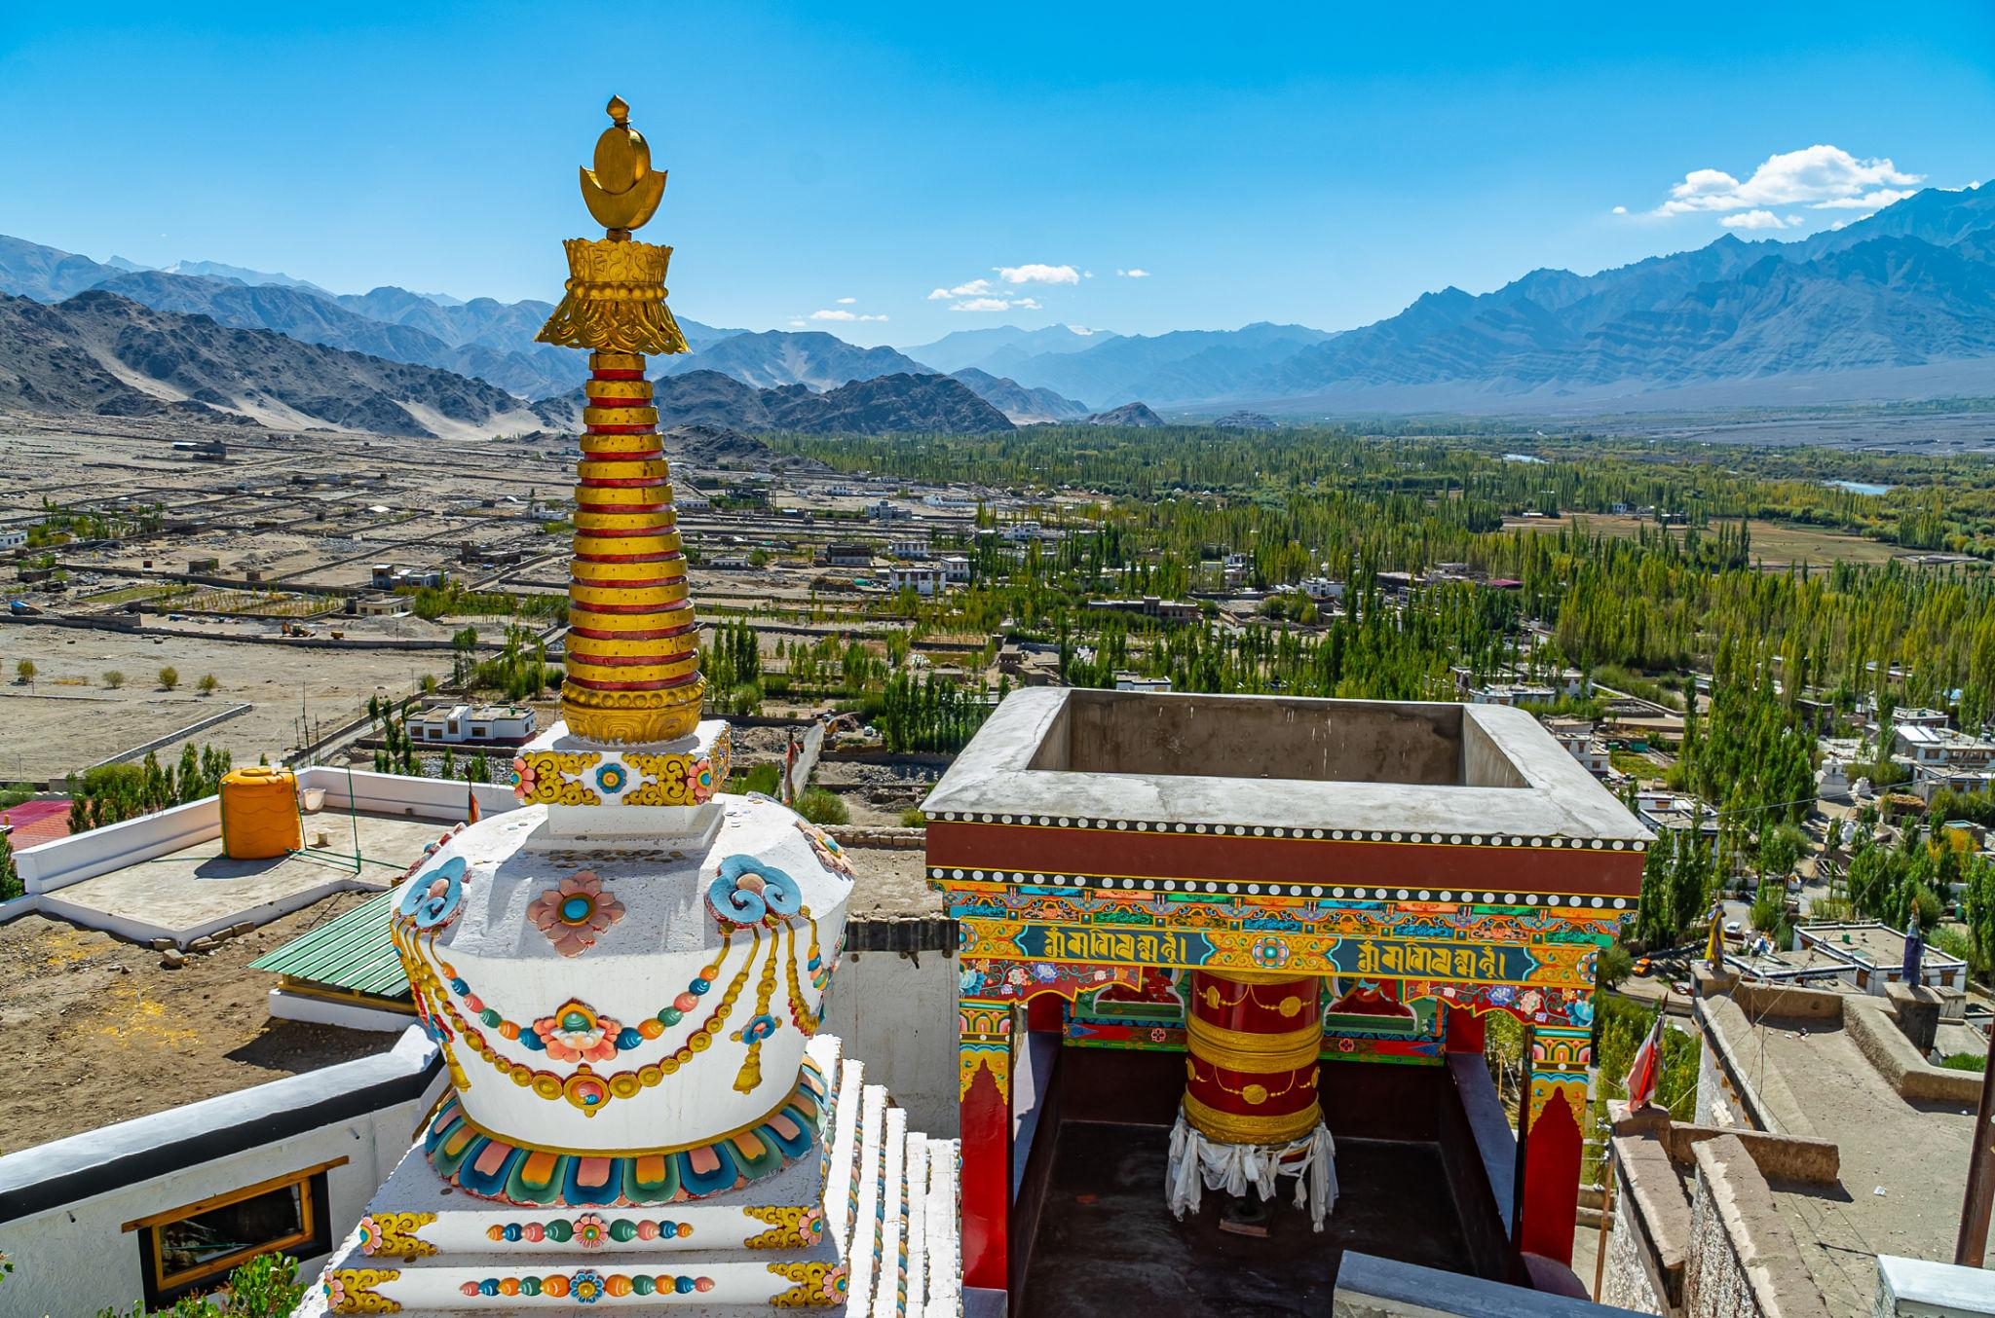
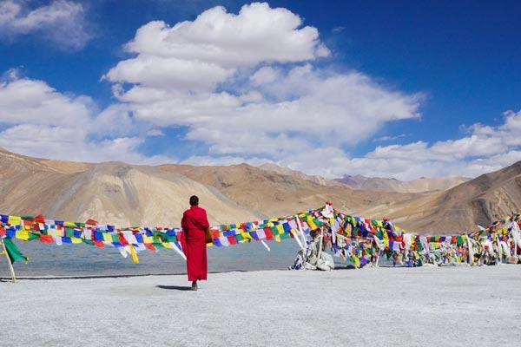
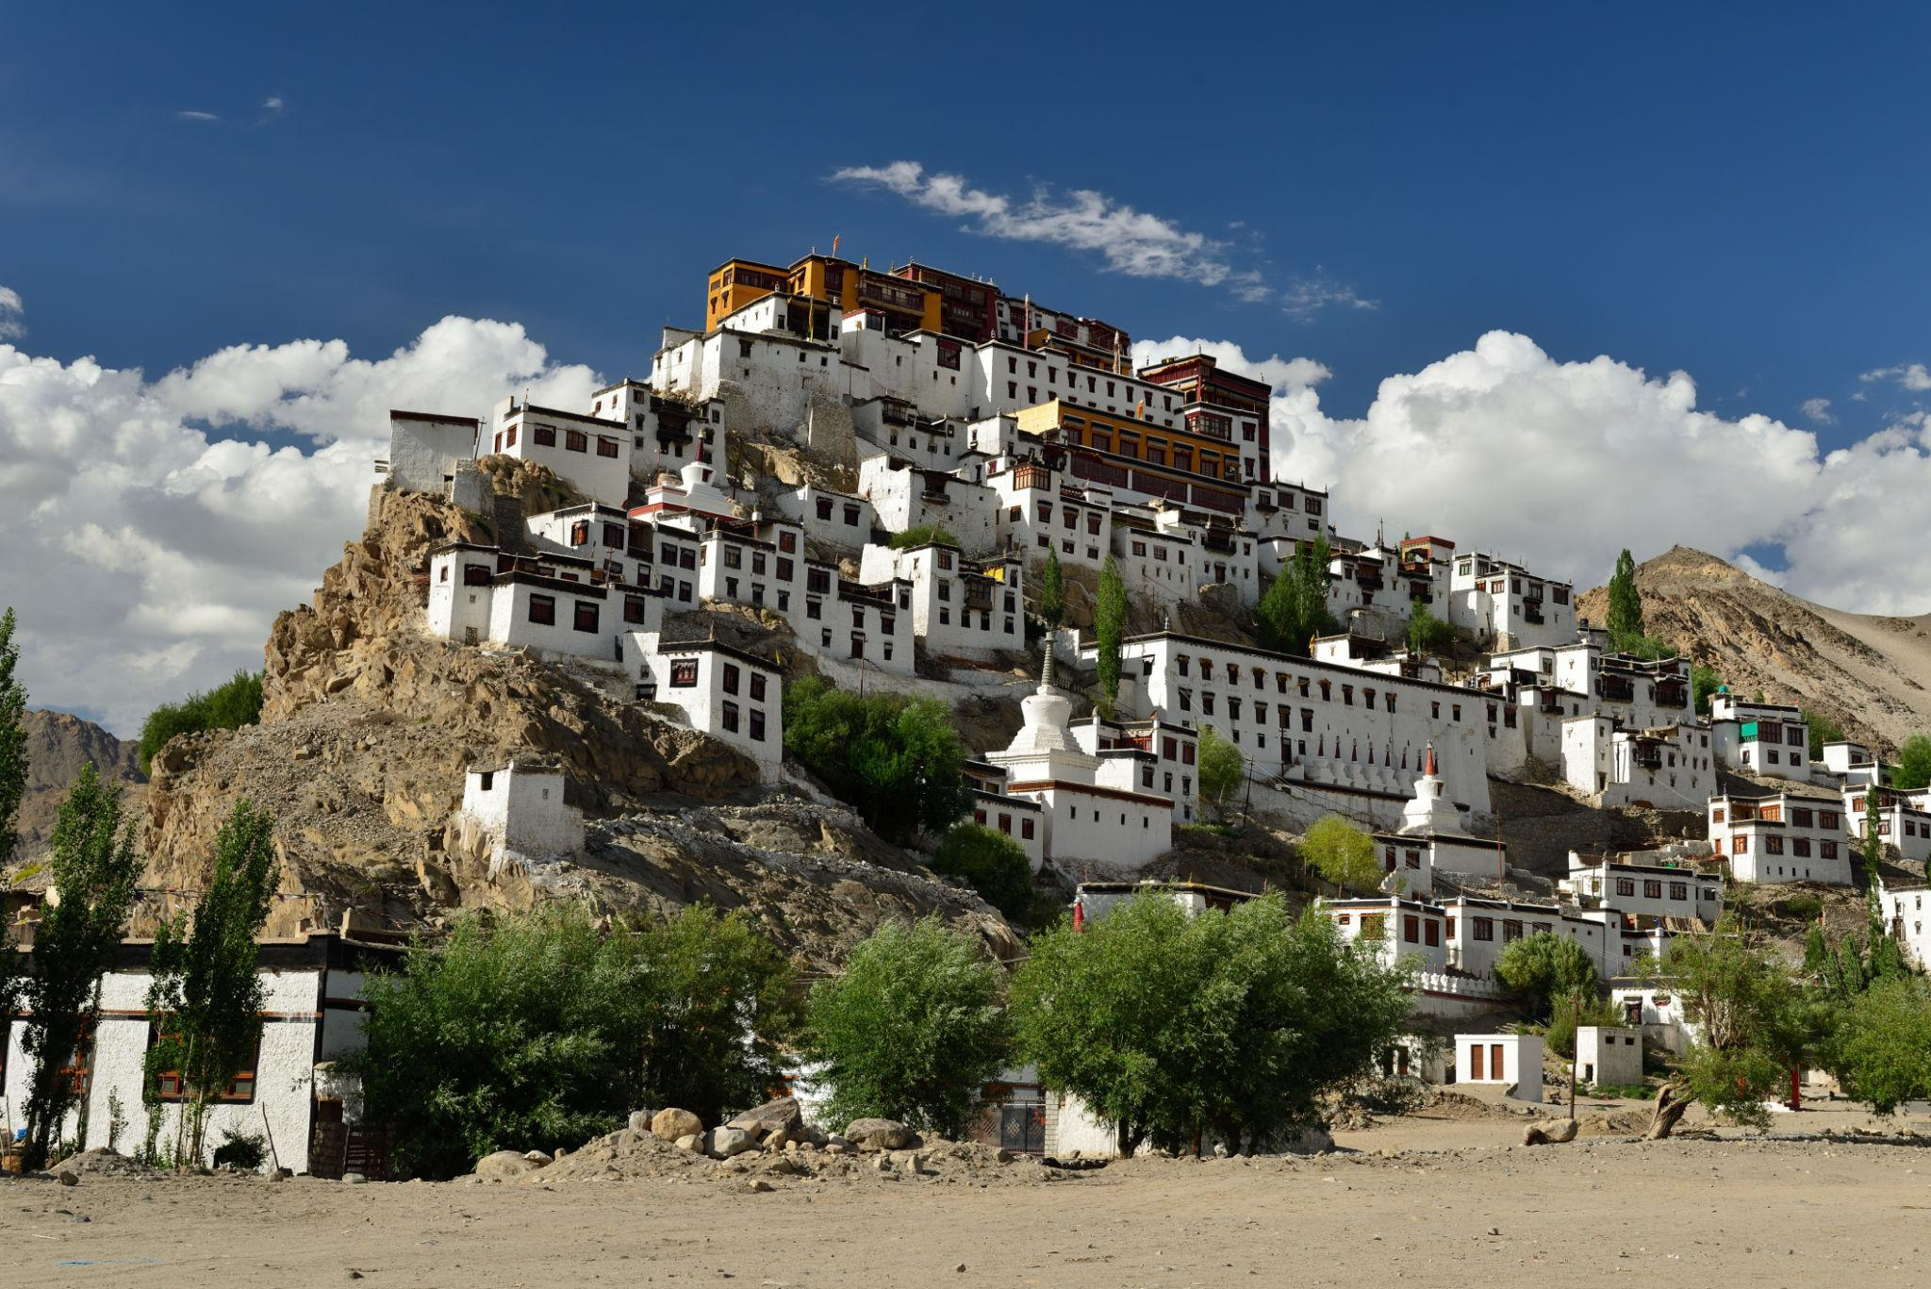
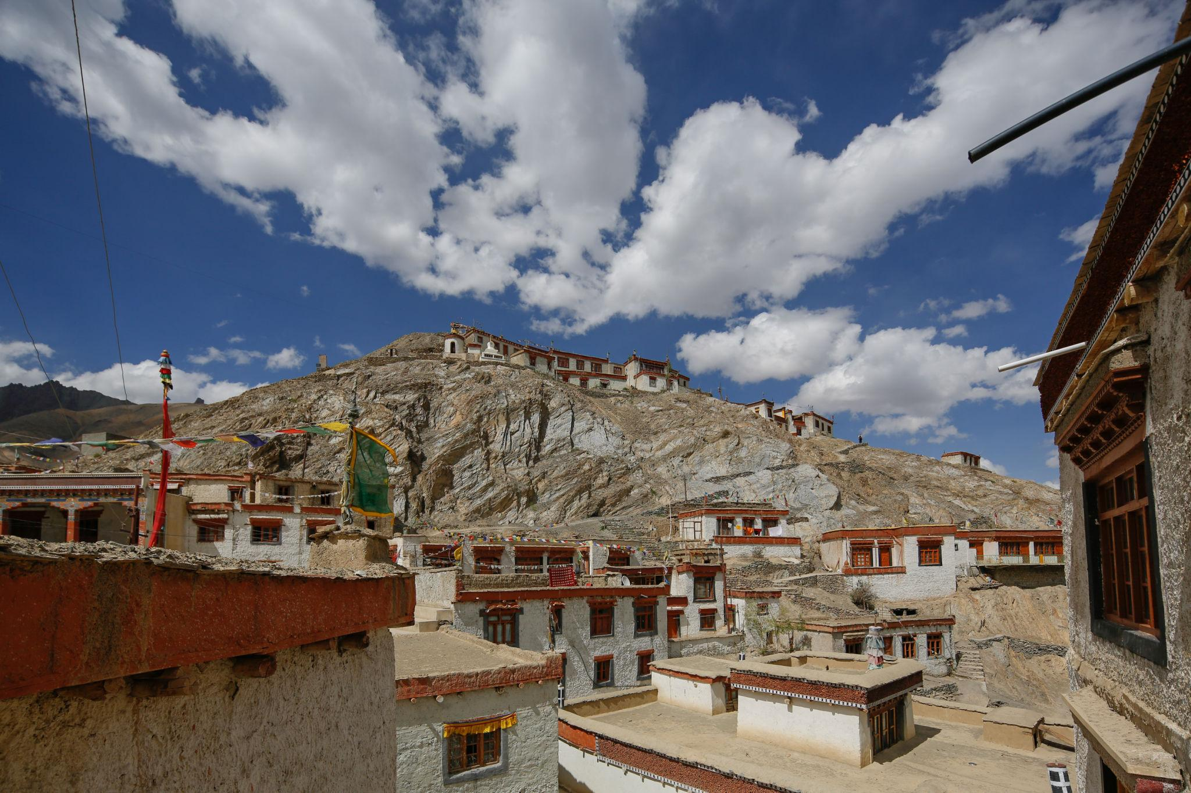
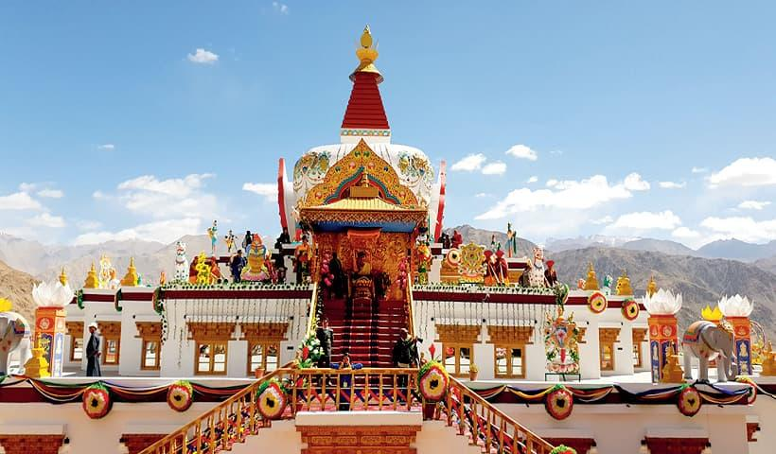
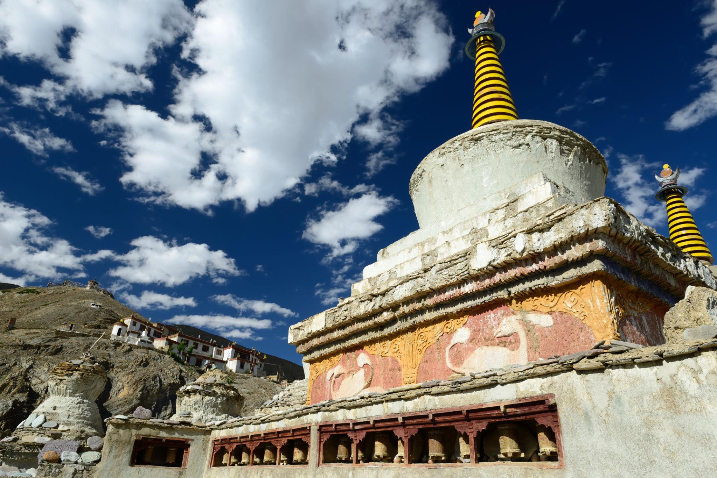
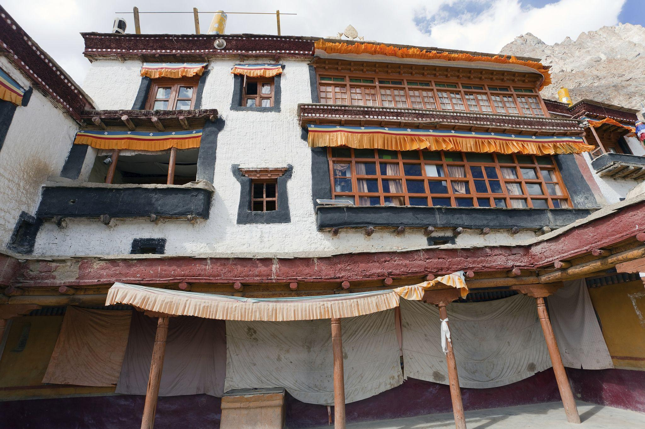
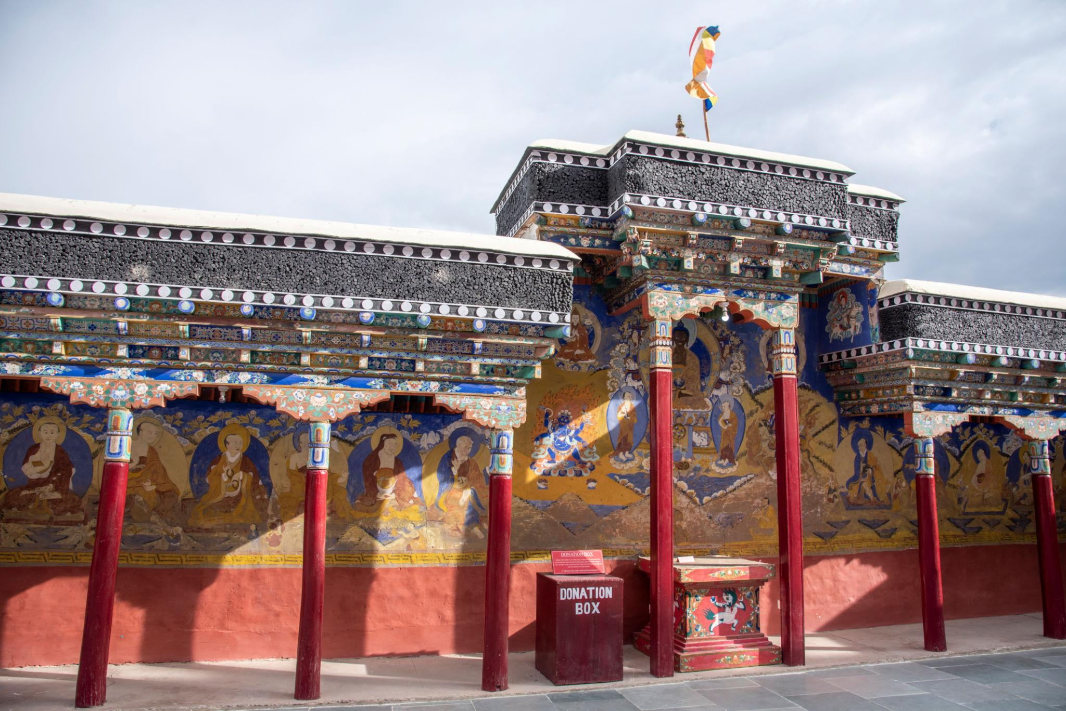

Best Things to Do in Leh Ladakh
- Ride bikes through mountain passes
- Camp near Pangong Lake
- Explore monasteries & Buddhist culture
- Enjoy river rafting on Zanskar River
- Experience ATV rides in Nubra Valley
- Trek in Himalayan landscapes
- Watch star-filled night skies
- Enjoy scenic photography

Best Time to Visit Leh Ladakh
Season | Months | Weather
Summer | May – September | Best for sightseeing & road trips
Winter | October – February | Snowfall & frozen landscapes
The best time to visit Leh Ladakh is from May to September.

How to Reach Leh Ladakh
By Air
Main airport:
- Kushok Bakula Rimpochee Airport
Direct flights available from:
- Delhi
- Srinagar
- Chandigarh
By Road
Popular road trip routes:
- Manali to Leh Highway
- Srinagar to Leh Highway
These routes are open mainly during summer.

Famous Foods to Try in Ladakh 🍲
- Thukpa
- Momos
- Skyu
- Butter Tea
- Tibetan Bread
- Yak Cheese Dishes

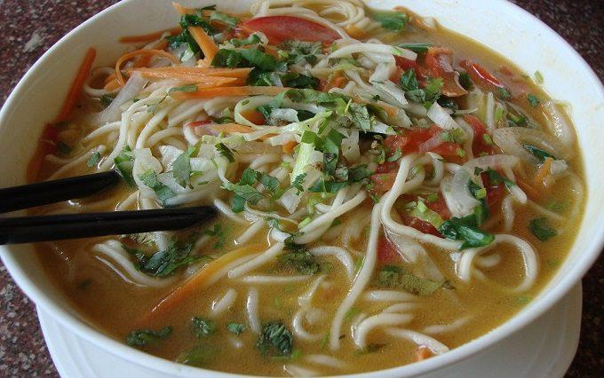
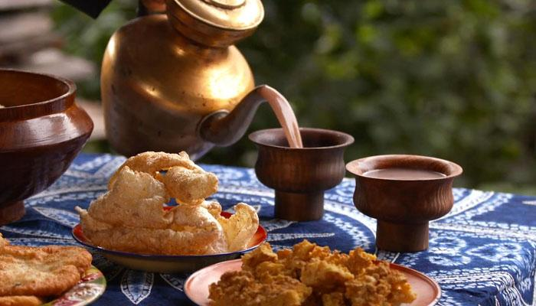



Luxury Experiences in Leh Ladakh ✨
- Luxury mountain camps
- Private bike expeditions
- Glamping near Pangong Lake
- Helicopter sightseeing tours
- Wellness retreats
- Premium adventure tours
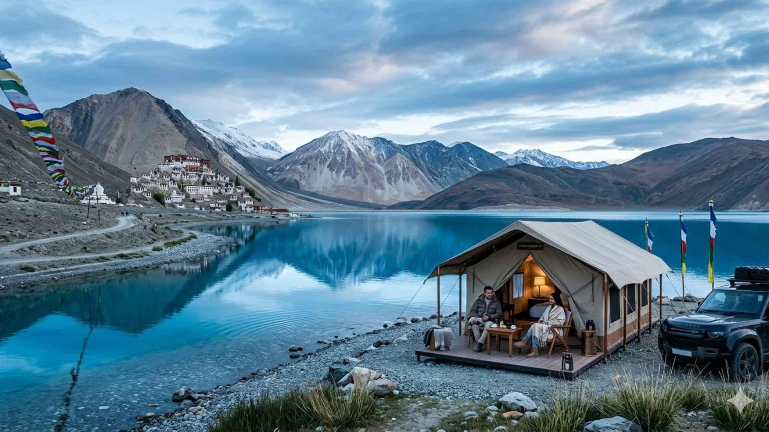
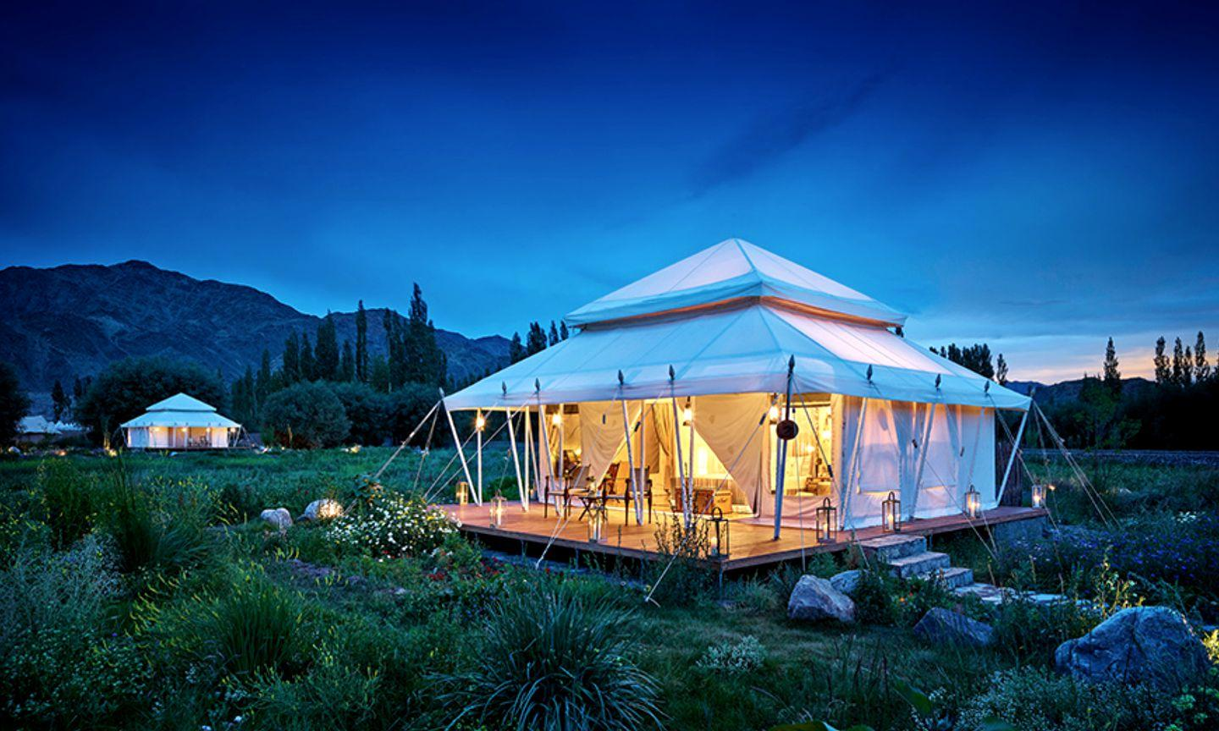
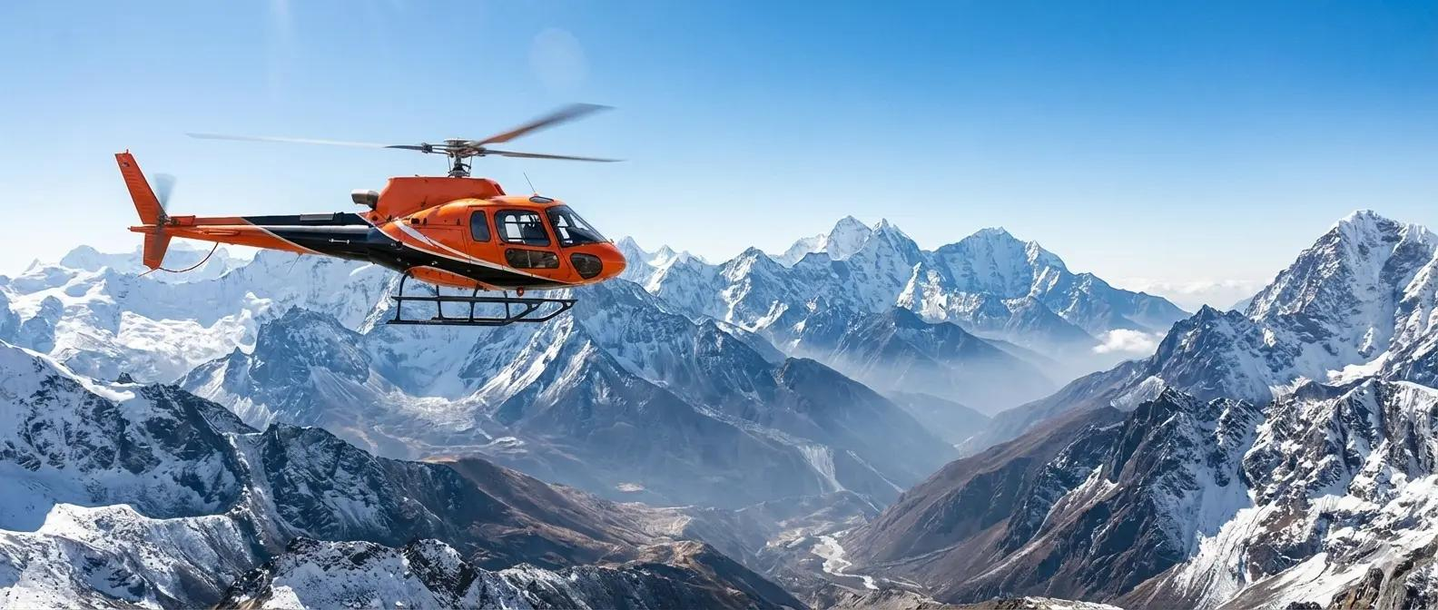
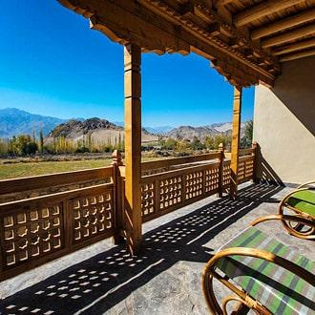
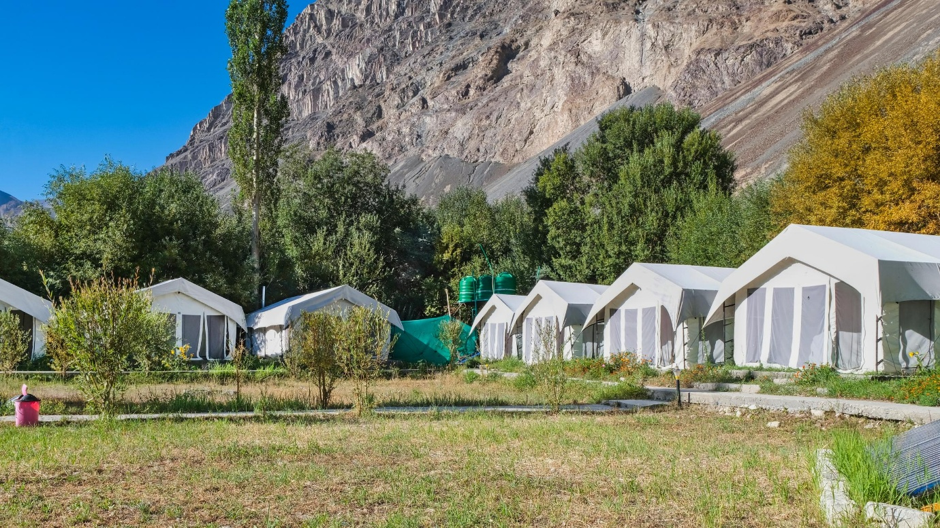
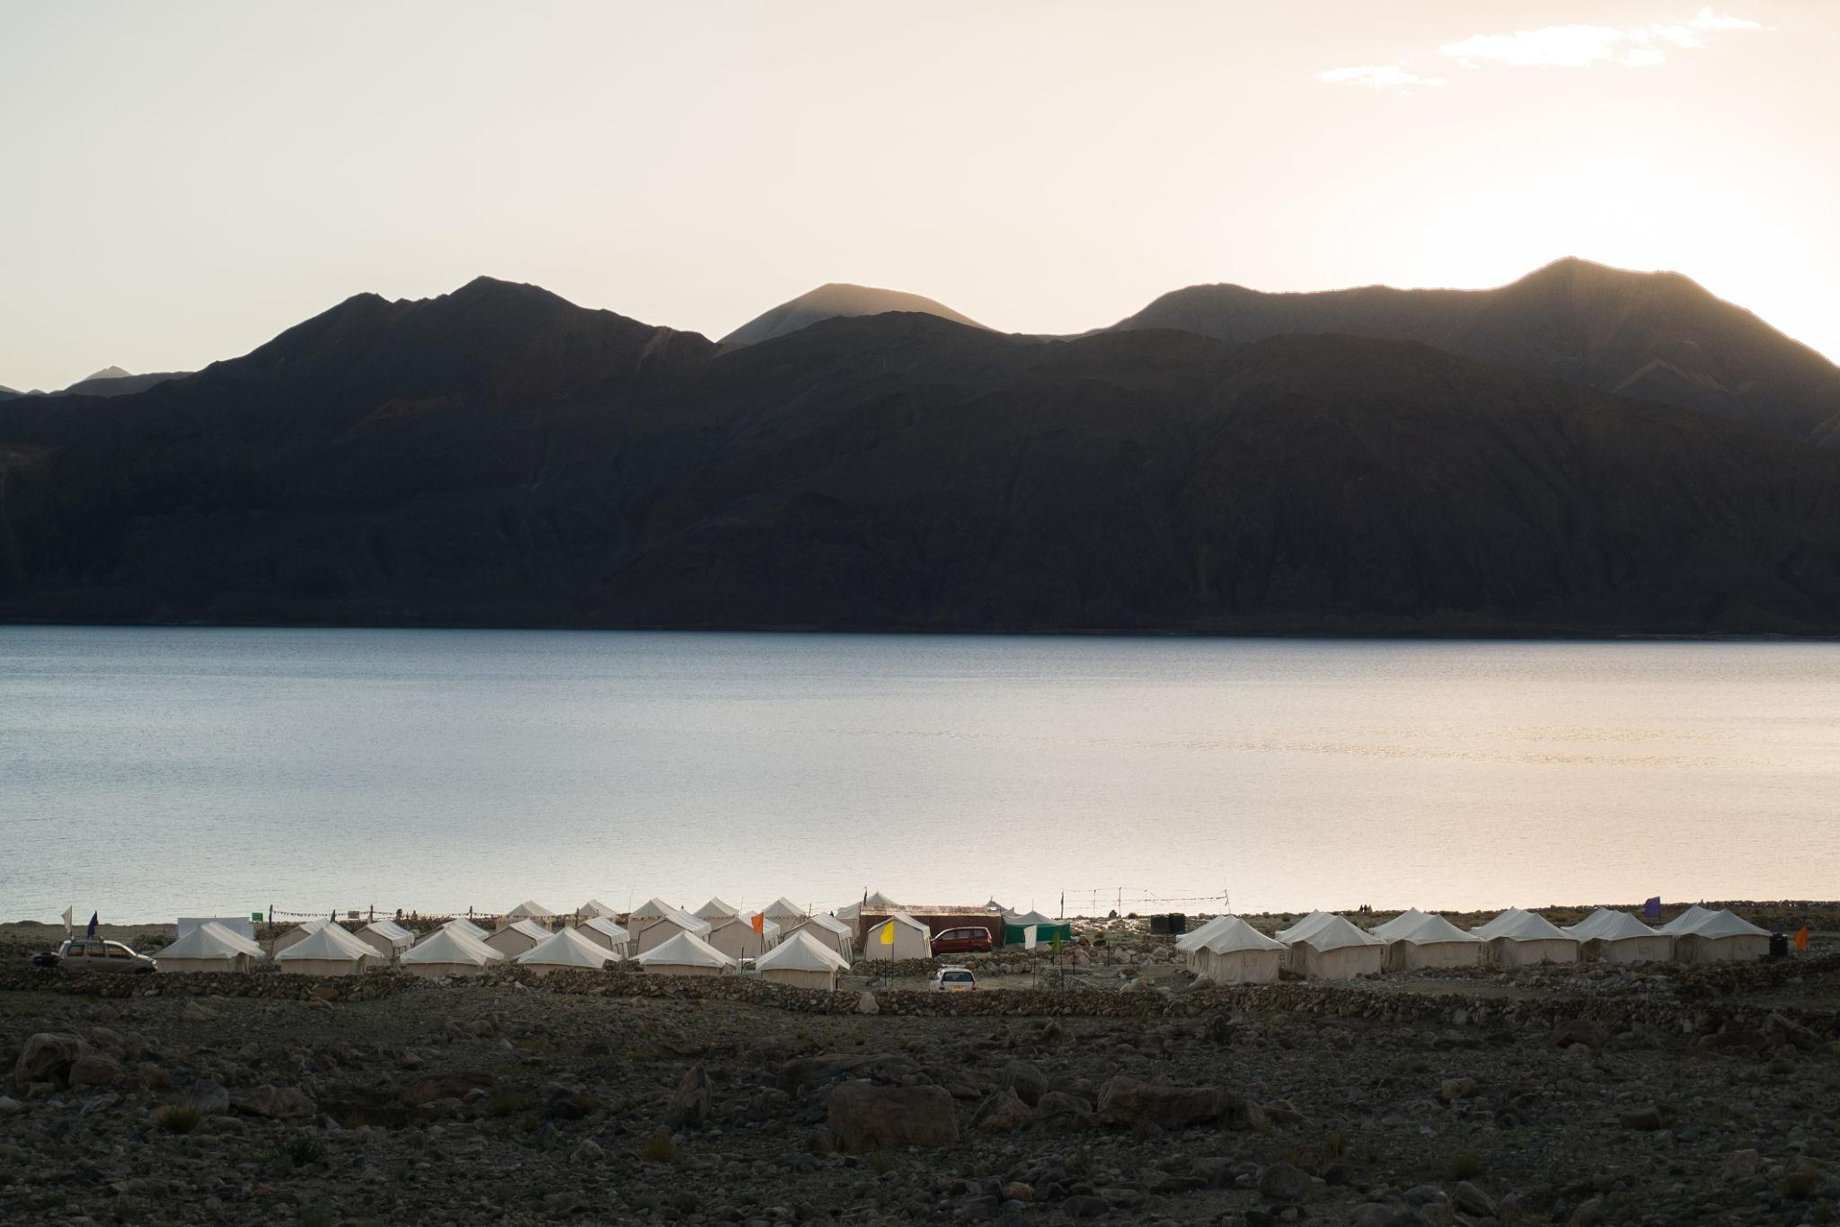

Leh Ladakh Travel Tips
- Acclimatize properly to high altitude
- Carry warm clothing even in summer
- Stay hydrated
- Carry necessary medicines
- Avoid heavy activity on first day
- Keep valid ID proofs & permits

Why Choose INTRO TRAVELS INDIA for Leh Ladakh?
With INTRO TRAVELS INDIA, you get:
- Customized Leh Ladakh tour packages
- Adventure & bike tour arrangements
- Luxury camps & hotel stays
- Comfortable transport facilities
- Guided sightseeing tours
- Group departures & private tours
- Permit assistance
- Family & honeymoon packages
Leh Ladakh is a destination where majestic mountains, crystal-clear lakes, thrilling adventures, spiritual peace, and unforgettable road journeys come together to create one of India’s most extraordinary travel experiences.

